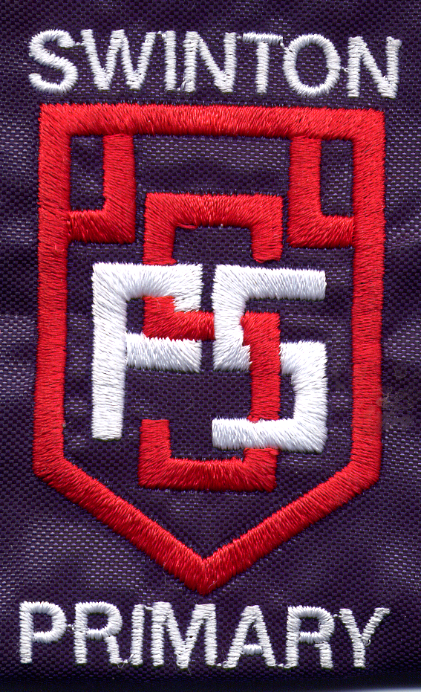
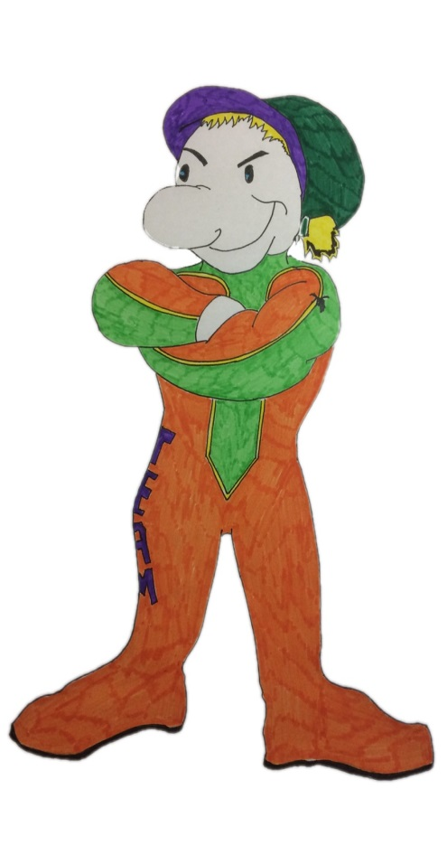

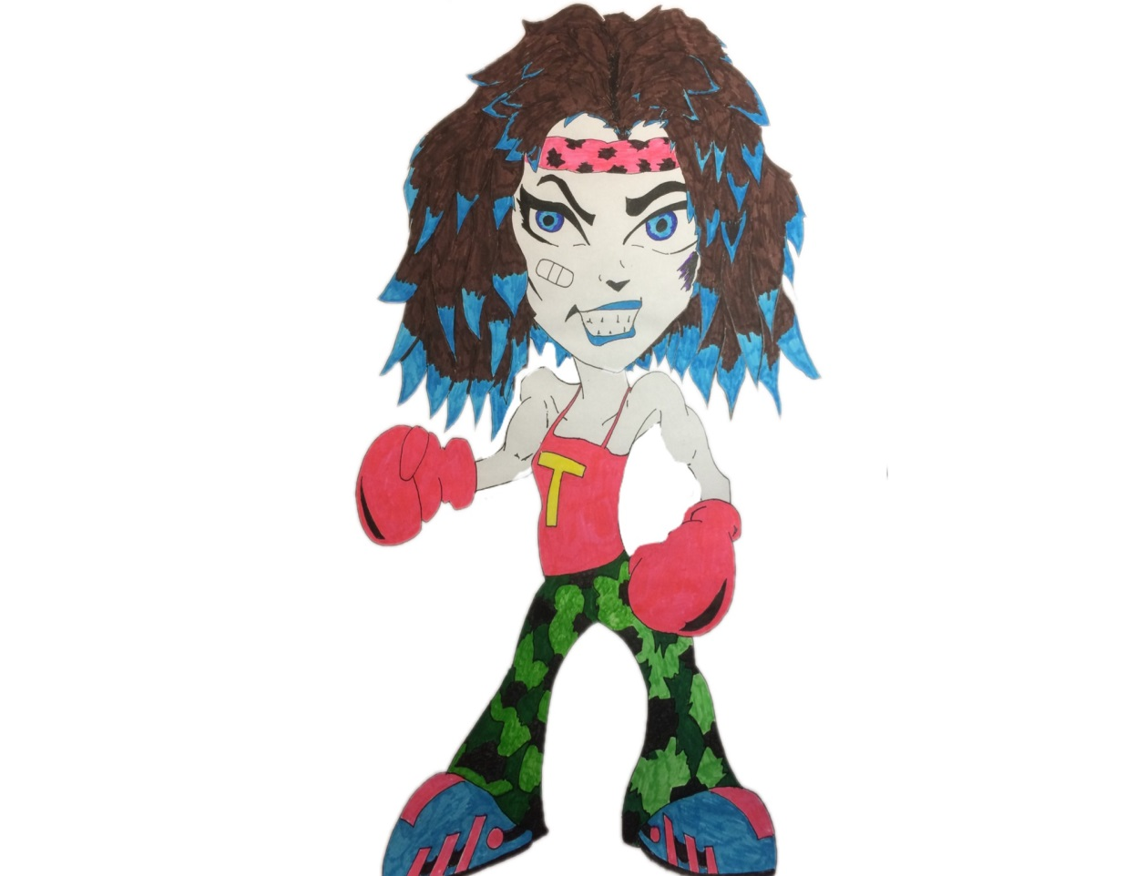
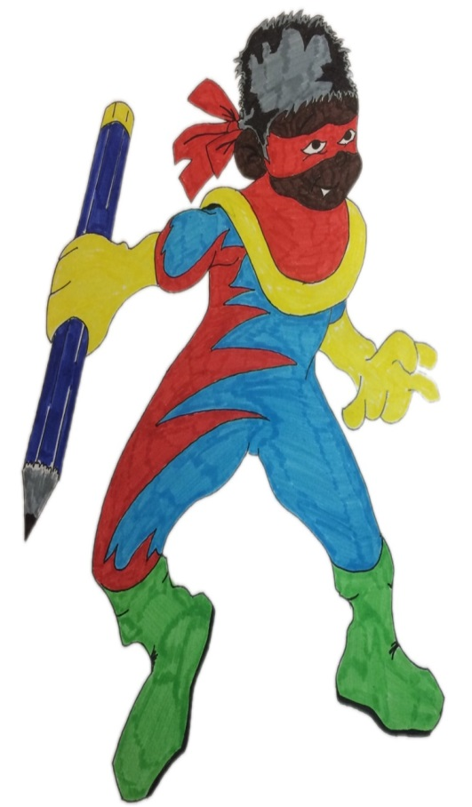

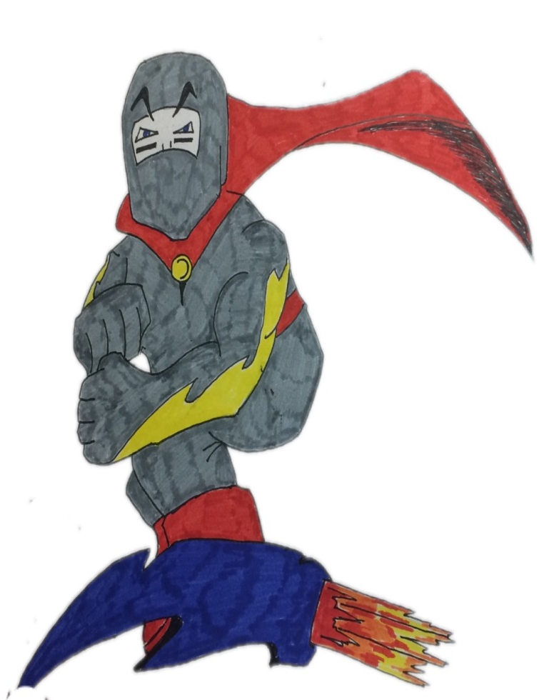

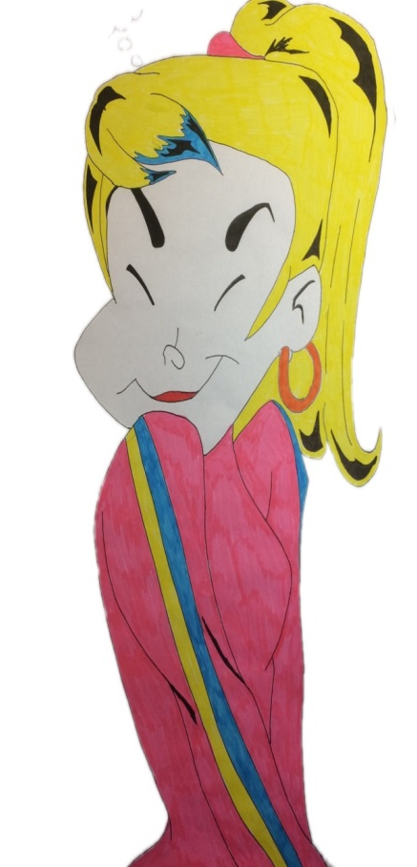
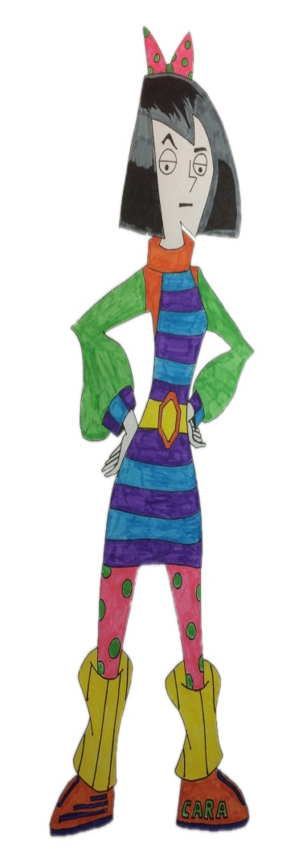
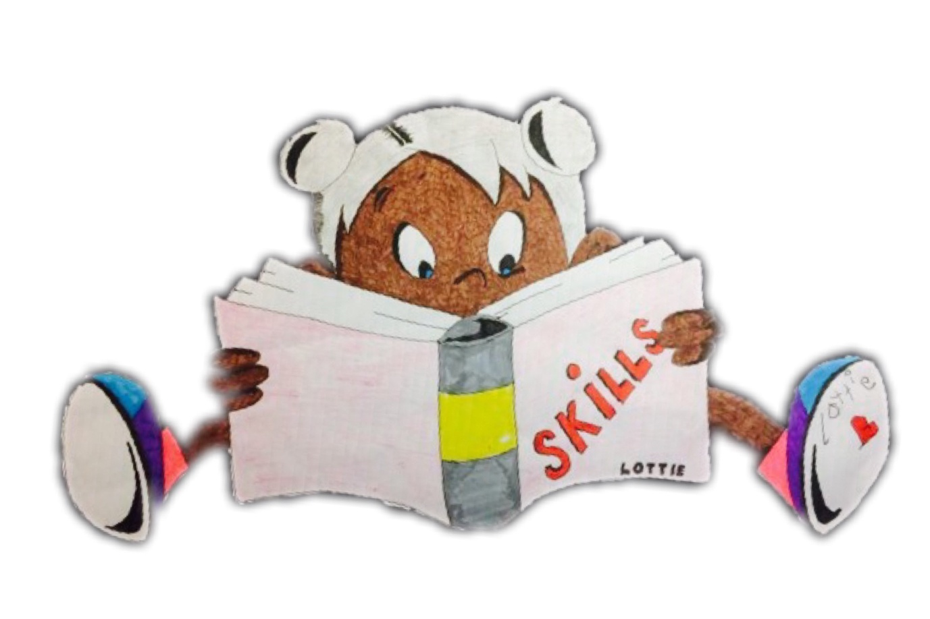
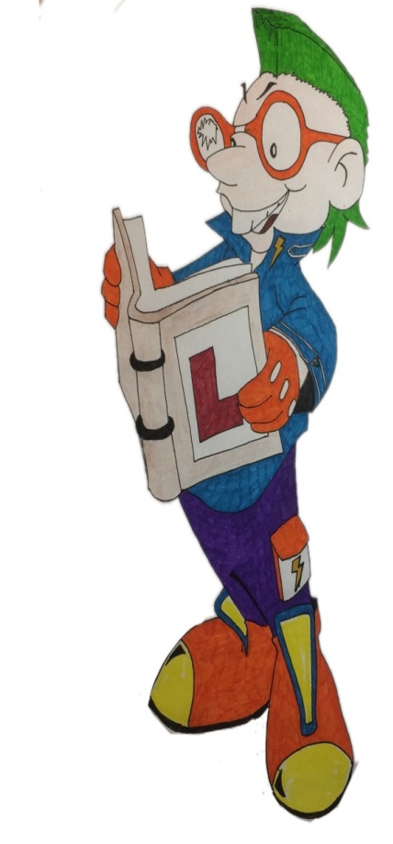

Swinton Primary School
Celebrating Success
Term 1 Achievement Assembly
11th October 2017


To be the best
we can be we need…
Trust, Care, Happiness
Responsibility& Respect

At the end of every term in Swinton Primary we have a special whole school assembly to celebrate our children’s achievements both in school and out of school. We thought it would be nice to share this fantastic news with parents & carers.
Values Award
P1 Alistair Macrae
P2 Rory Harvey
P3/2 Aarron Ross
P4/3 Ana Downie
P4 Ava Tyczynski
P5 Myles Mitchell
P6 Mason Roden
P7/6 Olivia Telfer
P7 Lee Smith
Rights Respecting School Awards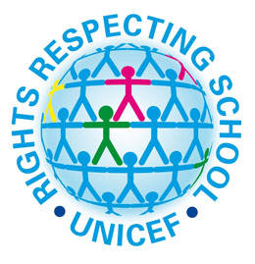

P1 Jayden May
P2 Mollie Defalco
P3/2 James Duncan
P4/3 Stephen Tincknell
P4 Jia Ying Cao
P5 Alistair Logan
P6 Taylor Dines
P7/6 Layla Cosh
P7 Brooke Anderson

Questioning Master - for asking questions to show you are interested in learning – just like Questioning Quin.
Max McFarlane, Kai Black, William Smith, Robbie Simpson, Aaron Smillie,
Emma Dickson, Bobby Sewell, Lewis Irwin, James Buchanan.

Creative Thinking – for thinking of different ideas and solutions – just like Creative Callum.
Jay Gibson, Layla Rana, Indie Scott, Kirk Simpson, Jack Morrison, Brodie Gallagher, Jodi O’Neill, Daisy McAuley, Malcolm McCallum, Kyle Bambridge.

Mastering Mistakes - for recognising that mistakes are important because you can learn from them - just like Max the Mistake Maker.
Sophie O’Brien, Sophie Dunn, Jude Hutton, Kai Burrell, Abi Ferguson,
Madiha Shakeel, Darcey Barcley, Finlay Dempster, Ethan Green.

Learning Legend - for sharing enthusiasm for learning and enjoying a challenge - just like Learning Lucy!
Harris Campbell, Tyler Ralston, Cole Webster, Amber Keenan, Hannah McMurdo, Rachel McMurdo, Brooke Philp, Keira McLaughlin-Key, Gary Monteith.

Fabulous Focus - for managing distractions and focusing on their work - just like Concentrating Cara!
Jessica Harland, Kayla Smith, Eva Boyd, Kirsten Downie, Marcus Sereika, Ellen Dong, Amy Ross, Robert Ainslie, Eva Murdoch.

Top Team Player - for working with others and being co-operative - just like Tom the Team Player!
Mason Owens, Callum Love, Poppy McAuley, Layla Cosh, Josh Meikle, Ben Devine, Kalvyn Ferguson, Tia Tolland, Macie Mallon.

Showing Resilience - for never giving up - just like Tough Tina!
Jayden Stewart, Ava Burry, Sophie Dines, Eilidh Dunn, Aaron Haining, Ellie McCloy, Talia Gunning, Kailyn McCall, Scott Gunning, Jayden Reid, Olivia Ross.

Practising Poppy - for continuing to practise new skills and develop new abilities - just like Practising Poppy!
Cerys Laurie, Sophia Gallagher, Sophia Watts, Layla McFall, Kelsi Thom,
Norah Marshall, Billy Eardley, Jay Mackay, Eva Baillie.

