Home Learning
Class: P3/2 Date:
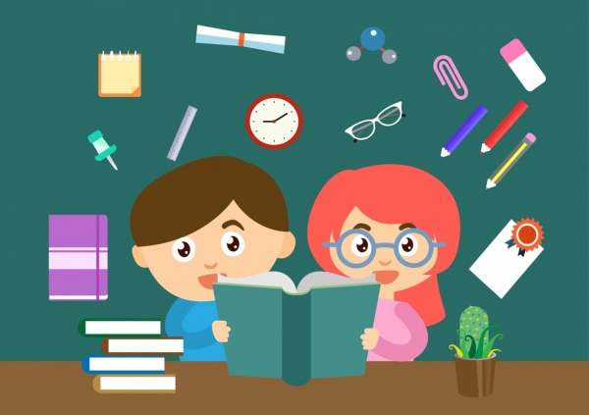
Please use the following information to discuss your child’s learning with them.
Literacy

We are learning to…
- Use describing words when talking about a character in a book.
- Use capital letters, finger spaces and full stops in all our sentences.
- Join our handwriting.

Reading
Please ensure your child is reading regularly. In addition to school reading books, please read a range of non-fiction and fiction texts to your child.

Reading and writing common words
Please practise reading, writing and spelling the words in your child’s word box. Please see the activity sheet for interactive games and activities that can make this fun for you all.

Numeracy

We are learning to…
- Count in 2s, 5s and 10s from any number within 100.
- Read half past, o’clock, quarter to and quarter past times on an analogue clock.
- Find the missing number in addition and subtraction sums.

Other Curricular Areas: Scotland

We are learning…
- About a variety of foods farmed and produced in Scotland.
- To use maps to find out about different landscapes local to where we live.
- To create, cook and experience traditional Scottish recipes.

Learning Log

Please complete your learning log review to share what you have been working on in school over the last month.

Websites to support learning

http://www.ictgames.com/lcwc.html

https://www.teachyourmonstertoread.com

https://www.topmarks.co.uk/ordering-and-sequencing/caterpillar-ordering

https://www.topmarks.co.uk/maths-games/hit-the-button

http://www.ictgames.com/fairyClock_v6.html

