Home Learning
Class: P7/6 Date:
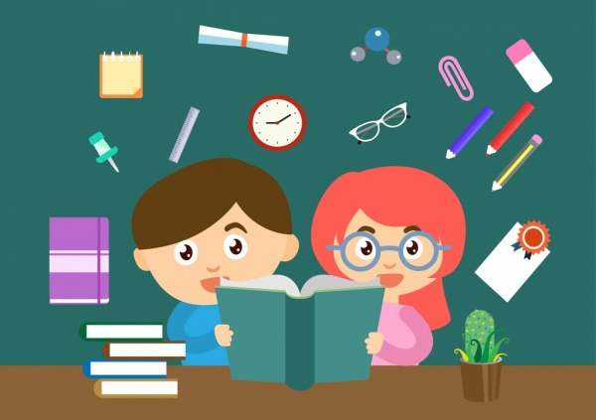
Please use the following information to discuss your child’s learning with them.
Literacy
- We are learning to connect our own experiences to those of characters in the book.
- We are learning to apostrophes to show possession.
- We are learning read with increased expression.

Please ensure your child is reading daily (see reading marker for information).

Spelling

Each week the children will focus on a spelling pattern in class. Four core words are provided each week, with the selected pattern. Pupils should also carry out a spelling activity each day (see active spelling ideas).
Please feel free to generate additional words if you want more challenge.
Week 1 | Week 2 | Week 3 | Week 4
cc | xc | ci | ti
accidentally | exchange | conscious | mention
accurately | exciting | especially | information
occasionally | exclude | precious | initial
accelerate | exclaim | suspicious | partial
Numeracy

We are learning to…
- Identify factors of numbers.
- Find the highest common factors of a pair of numbers.
- List prime numbers to 100.

Other Curricular Areas: Scotland

We are learning to…
- Identify features of Scotland’s landscape and can provide an explanation of how these are formed.
- Identify the impact of human activity on the environment.
- Suggest ways in which people can live in a more environmentally responsible way.

Learning Log

Please complete your learning log review to share what you have been working on in school over the last month.

Websites to support learning

www.spellingcity.com
www.primaryhomeworkhelp.co.uk/
www.worksheetgenius.com/
www.mathplayground.com/games.html
www.topmarks.co.uk/maths-games/hit-the-button

