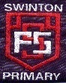

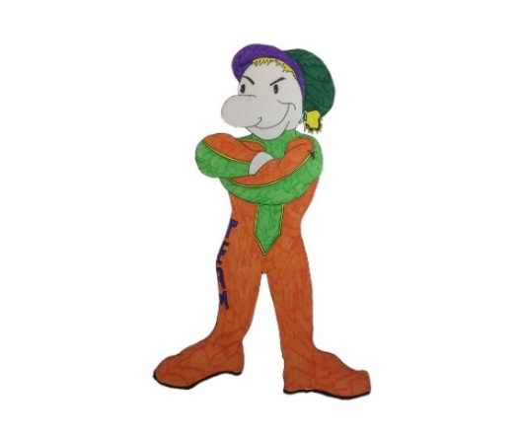

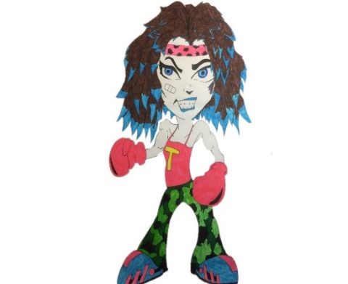

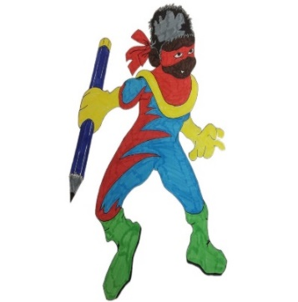

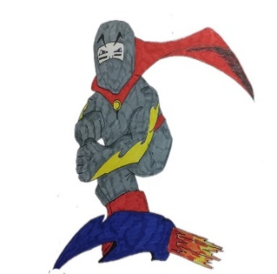

Mindset Marvels

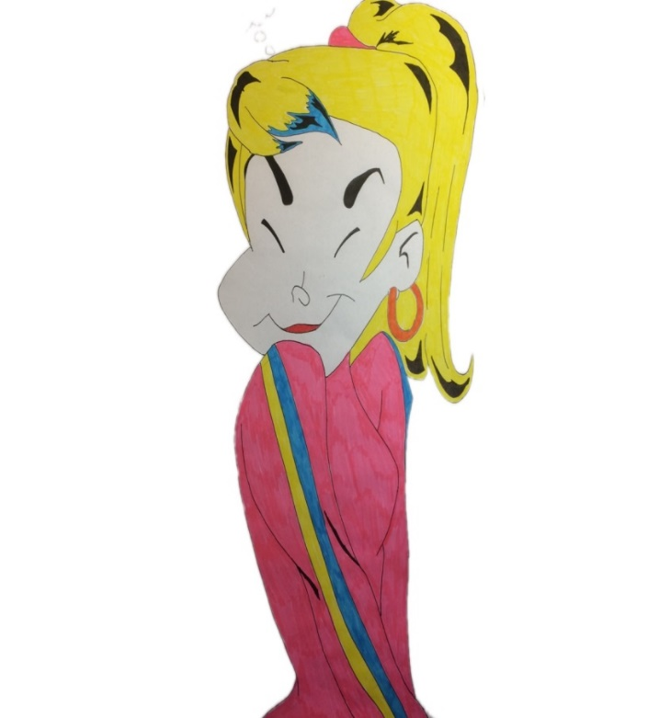

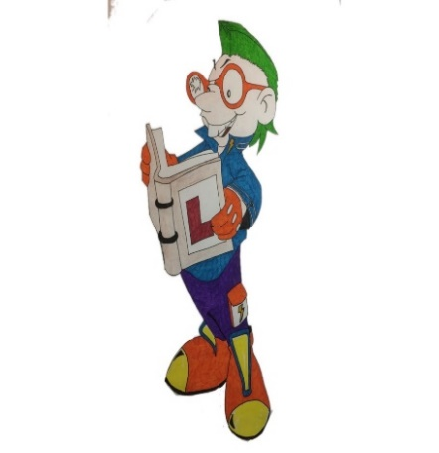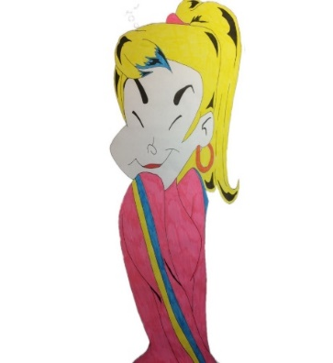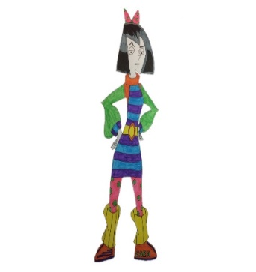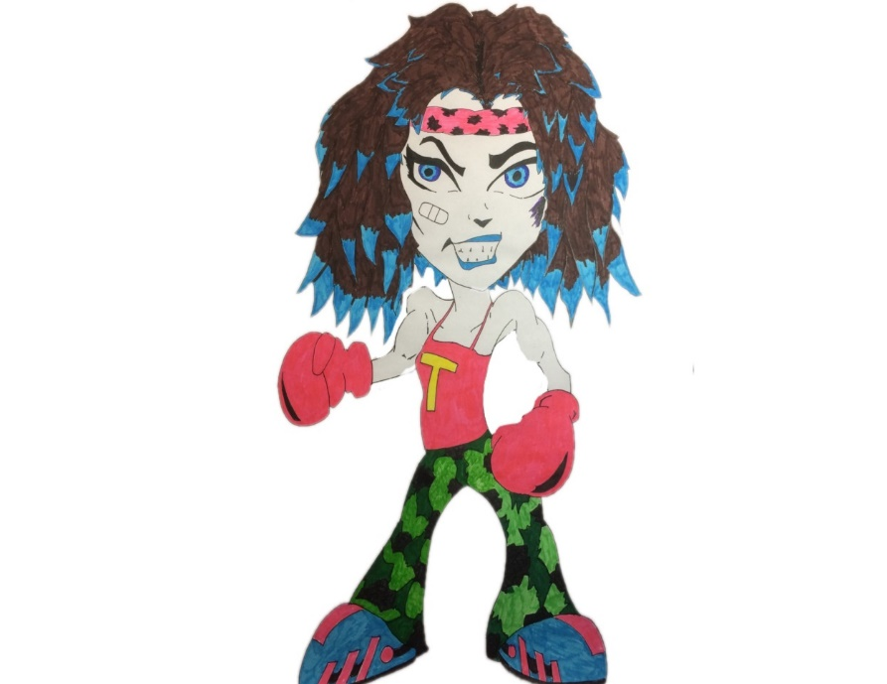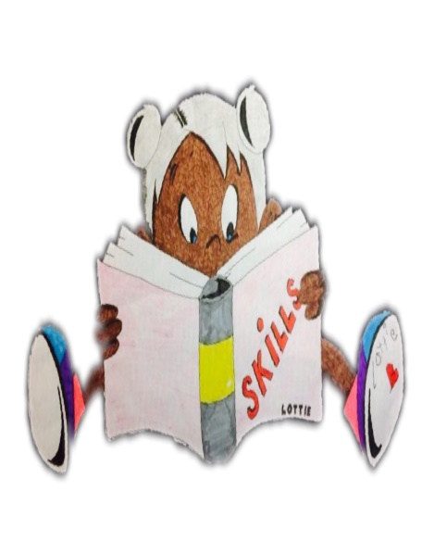

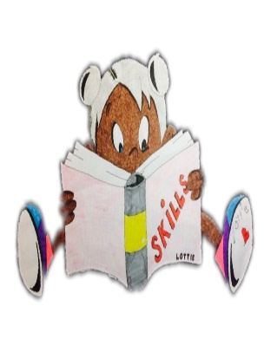





**Swinton Primary School**

**Celebrating Success**

**Term 2 Achievement Assembly**

**15th January 2025**



***To be the best***

***we can be we need…***

***Trust, Care, Happiness***

***Responsibility& Respect***

***At the end of every term in Swinton Primary we have a special whole school assembly to celebrate our children’s achievements both in school and out of school. We thought it would be nice to share this fantastic news with parents & carers.***



Values Award

P1 Heidi MacLachlan P2/1 Leah Freeman

P2 Aziz Thomas P3 Eva Strachan

P4/3 Penelope Queen P5/4 Jacob Haining

P6/5 Lewis Millar P6 Neve Defalco

P7 Miley Munn

**Library Legend –** for looking after the books in the Book Palace, showing respect for others while they are reading and loving our library.

**Lola-Rose Park, Franky Bambridge, Lexi Halliday, Mason Bain**

**Aria Ryan, Lucy Owens, Lewis Clinton, Ishaq Shabbir,**

**Robbie Logue.**

**Questioning Master -** for asking questions to show you are interested in learning – just like Questioning Quinn.

**Ollie Speedie, Logan McGurgan, Susie Hollywood**

**Angus McLellan, Eva Black, Aaron McGrath, Adele Collins**

**Finlay Trivett, Emily Logan.**

**Creative Thinking –** for thinking of different ideas and solutions – just like Creative Callum.

**Bonnie Noble, Harper Burns, Ari Groves, Cody Leat, Abigail Liu**

**Kaitlyn Dickson, Jakob McRobert, Sam Black, Erin Louden**

**Owen Dong, Rowan Simpson.**

**Mastering Mistakes** - for recognising that mistakes are important because you can learn from them - just like Max the Mistake Maker.

**Cassius Crawford, Sam Stevenson, Laughlin Ferrie,**

**Sophea Karimi, Hayley Scroggie, Jorgie Hannen, Poppy Mack,**

**Leona Wyatt, Amy-Grace Meechan.**

**Learning Legend -** for sharing enthusiasm for learning and enjoying a challenge - just like Learning Lucy!

**William Johnstone, Emily Sands, Aziz Thomas, Leon Rae,**

**Charlie McInnes, Louisa Johnstone, Aaron Craig,**

**Harris Cameron, Aria Scott, Emmie Roden.**

**Fabulous Focus -** for managing distractions and focusing on their work - just like Concentrating Cara!

**Harris McAra, Ellie Milligan, Ella Hand, Alyvia Simpson,**

**Harper Kerr, Carson Wylie, Millie McMann, Evie Campbell,**

**Alistair Tincknell, Cadhla Carvil.**

**Top Team Player -** for working with others and being

co-operative - just like Tom the Team Player!

**Jaxon Speedie, Halle McCormack, Harris Clinton,**

**Ashton Harwood, Alix McClelland, Lewis McGurgan**

**Elliot Mackay, Violet Tetmichalis, Jude Carr.**

**Showing Resilience -** for never giving up - just like Tough Tina!

**Junior Simpson, Hallie Wilson, Lacey Logue, Aubree Adamson,**

**Eva Ferguson, Lucy McKay, Caleb Harland, Carly Hemphill,**

**Jayce McGregor, Ameera Abbas.**

**Practising Poppy -** for continuing to practise new skills and develop new abilities - just like Practising Poppy!

**Hania Waris, Krystyna Hannah, Millie McGuire, Mohammad Ali,**

**Freya McFarlane, Raven Allan, Max Meechan, Sofia Robinson**

**Ayda Owens, Thomas Fagan**.**