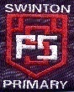

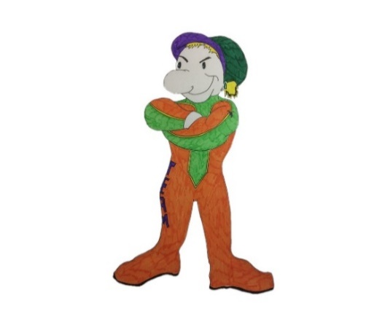

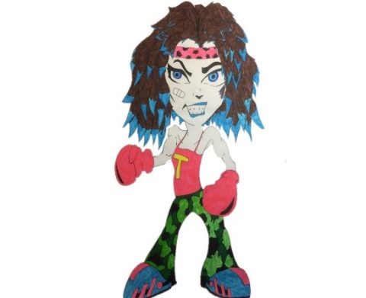

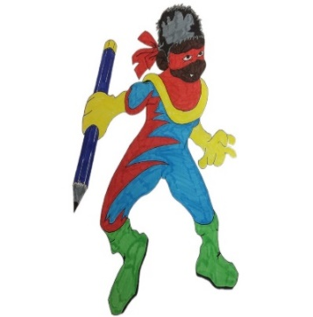

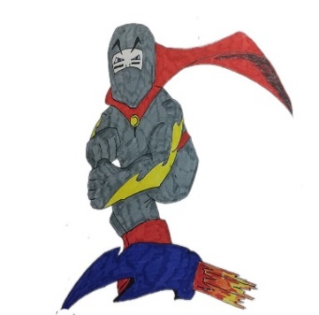

Mindset Marvels

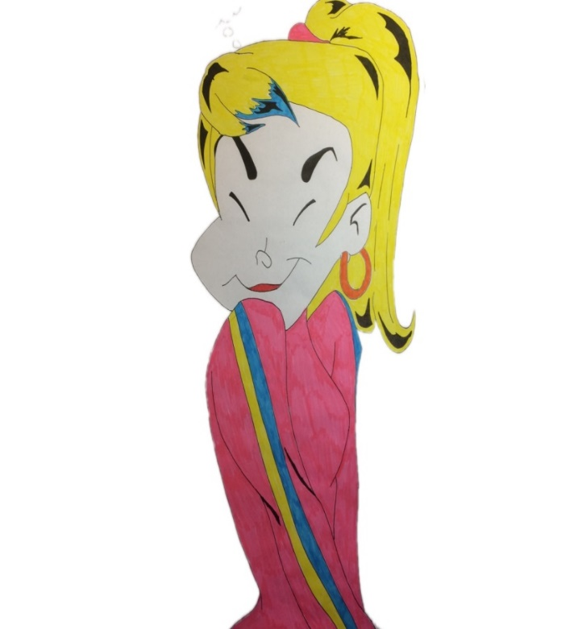

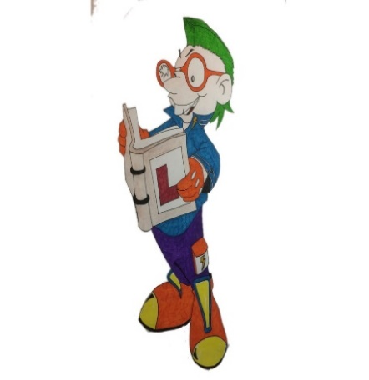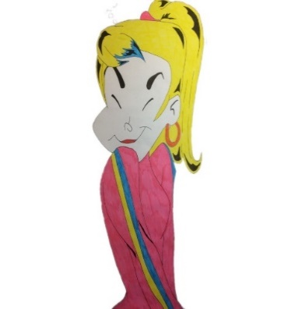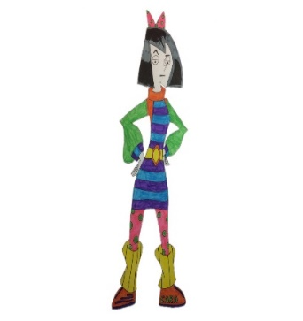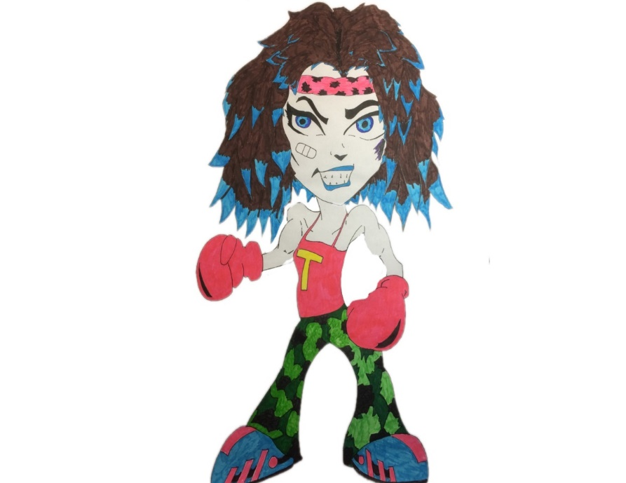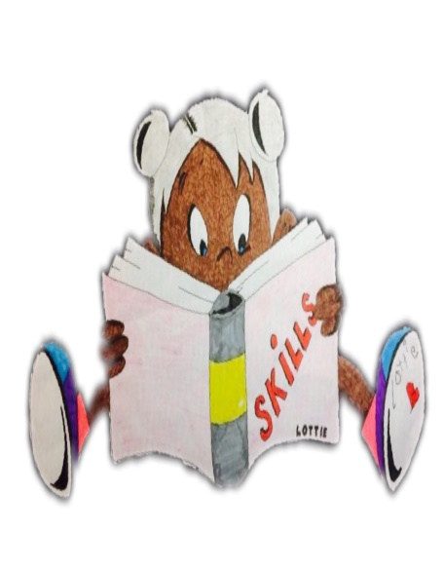

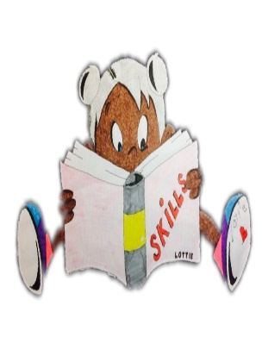





**Swinton Primary School**

**Celebrating Success**

**Term 3 Achievement Assembly**

**3rd April 2025**



***To be the best***

***we can be we need…***

***Trust, Care, Happiness***

***Responsibility& Respect***

***At the end of every term in Swinton Primary we have a special whole school assembly to celebrate our children’s achievements both in school and out of school. We thought it would be nice to share this fantastic news with parents & carers.***



Values Award

P1 Bonnie Noble P2/1 Ellie Milligan

P2 Susie Hollywood P3 Olivia Kennedy

P4/3 Darcy Wallace P5/4 Raven Allan

P6/5 Lewis Clinton P6 Isla Tyczynski

P7 Max Allan

**Library Legend –** for looking after the books in the Book Palace, showing respect for others while they are reading and loving our library.

***Lucie Kerr, Sam Stevenson, Aaran Liu, Oliver Quinn, Kylan Cornelly, Kaitlyn Dickson, Dylan Broadley, Jorge Kerr,***

***Fletcher Mitchell.***

**Questioning Master -** for asking questions to show you are interested in learning – just like Questioning Quinn.

***Axel Sneddon, Ellie Livingstone, Betsy Trivett, Kieran McFadden, Giovanna Reynolds, Eilidh Love, Sam Morrison, Orla Leishman, Lucie Dickson*.**

**Creative Thinking –** for thinking of different ideas and solutions – just like Creative Callum.

***Bonnie Cummins, Sonny Tolland, Lewis Hume, Mason McLean, Emilie Mae McAllister, Cara Simpson, Hayden Gallagher, Cassia Mallon, Miley Munn and Alyssa O’Donnell.***

**Mastering Mistakes** - for recognising that mistakes are important because you can learn from them - just like Max the Mistake Maker.

***Heidi MacLachlan, Myla Thomson, Thomas Eminson, Archie Moore, Freddie Forrester, Kayleb Brown, Layla Fullarton, Mason Kent, Jack Connelly, Thomas Fagan.***

**Learning Legend -** for sharing enthusiasm for learning and enjoying a challenge - just like Learning Lucy!

***Joshua Trelogan, Maya O’Donnell, Farrell Short, Arran McQuade, Charlie Campbell, Lucy Owens, Brodie Wilson, Amilee Cornelly, Maisie Baggley, Zack McAuley.***

**Fabulous Focus -** for managing distractions and focusing on their work - just like Concentrating Cara!

***Billie McLean, Arlo McClelland, Callum Owens, Ben Anderson, Edie Tyczynski, Leyla Ralston, Meghan Reilly, Layla Calman,***

***Robbie Allen.***

**Top Team Player -** for working with others and being

co-operative - just like Tom the Team Player!

***Halle Taylor, Layla Gray, Jack Armstrong, Autumn Kent, Summer Rae, Jacob Haining, Carson Lochrane, Eilidh McNicol,***

***Charlie Rowat.***

**Showing Resilience -** for never giving up - just like Tough Tina!

***Preston Hood, Aria McKinlay, Logan Tetmichalis, Frankie Kerr, Aaron Harland, Alfie Brockie, Nina Pawlak, Amelia Donohoe, Harrison Burns, Sam Flynn-Hardie*.**

**Practising Poppy -** for continuing to practise new skills and develop new abilities - just like Practising Poppy!

***Hallie Martin, Halle McGregor, Isla Gray, Lena Kalinowska, Ollie Brockie, Neve Nelson, Josh Hume, Millie McMann, Noah Haining, Carla MacKinnon*.**