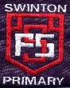

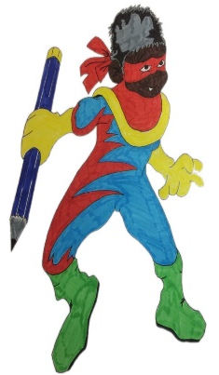

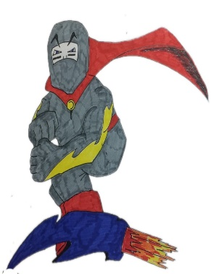

Mindset Marvels

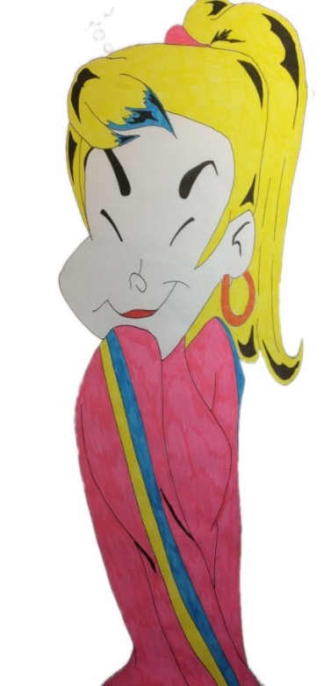

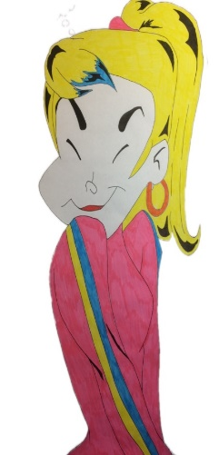
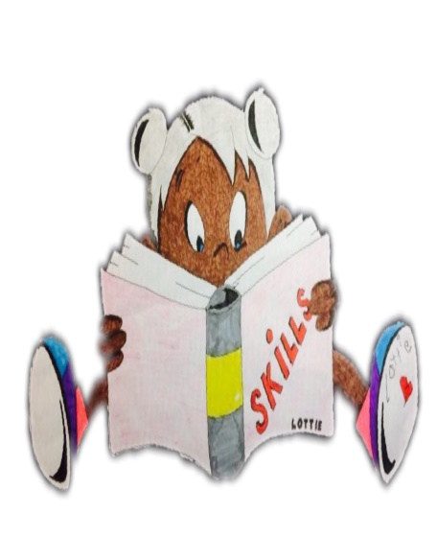
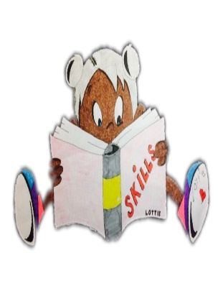

Swinton Primary School
Celebrating Success
Term 4 Achievement Assembly
10th June 2022

To be the best
we can be we need…
Trust, Care, Happiness
Responsibility& Respect

At the end of every term in Swinton Primary we have a special whole school assembly to celebrate our children’s achievements both in school and out of school. We thought it would be nice to share this fantastic news with parents & carers.
Values Award
P1 Katie Dickson
P2/1 Nina Pawlak
P3/2 Violet Tetmichalis
P3 Jorgie Kerr
P4 Alyssa O’Donnell
P5 Dylan Gauley
P6 Emma Dickson
P7 Ava Burry

Rights Respecting School Awards
P1 Leyla Ralston
P2/1 Max Meechan
P3/2 Lucy Owens
P3 Evie Campbell
P4 Miley Munn
P5 Sophia Watts
P6 Indie Scott
P7 Kailyn McCall

Questioning Master - for asking questions to show you are interested in learning – just like Questioning Quin.
Penelope Queen, Jorgie Hannen, Raven Allan, Mason Kent,
Harris Cameron, Fletcher Mitchell, Caleb Reilly, Karson Hannen,
Arran McIntyre.
Creative Thinking – for thinking of different ideas and solutions – just like Creative Callum.
Louisa Johnstone, Eva Black, Cassia Mallon, Sophia Paterson,
Jack Fawkes, Jack Hamilton, Charlie Burns, Angel Aird.
Mastering Mistakes - for recognising that mistakes are important because you can learn from them - just like Max the Mistake Maker.
Lewis McGurgan, Meghan Reilly, Brodie Wilson, Sam Black,
Lily McLellan, Aaron Haining, Norah Marshall, Aaron Smillie.
Learning Legend - for sharing enthusiasm for learning and enjoying a challenge - just like Learning Lucy!
Leyla Ralston, Akaalbir Singh, Charlie Campbell, Orla Leishman,
Blake Marshall, Owen Dong, Millie Paterson, Mollie Defalco,
Mark Buchanan, Lucas Wright.
Fabulous Focus - for managing distractions and focusing on their work - just like Concentrating Cara!
Jack Haining, Dylan Broadley, Ahmed Abdulwahid, Summer McGillivray, Max Allan, Jayden May, Ben Devine, James Duncan, Anna Downie.
Top Team Player - for working with others and being
co-operative - just like Tom the Team Player!
Josh Hume, Summer Rae, Noah Haining, Eilidh McNicol, Robbie Allen, Corey Martin, Rory Harvey, Carson Callaghan, Gordon Ritchie,
Kailyn McCall.
Showing Resilience - for never giving up - just like Tough Tina!
Alfie Brockie, Brody McCormack, Elliot Mackay, Ryan McKinlay,
Charlie Rowat, Leighton Halliday, Max Flynn-Hardie, Grey Pearson.
Practising Poppy - for continuing to practise new skills and develop new abilities - just like Practising Poppy!
Hayley Scroggie, Emilie-Mae McAllister, Poppy Mack, Myla McArthur, Mollie O’Brien, Adam Woodburn, Taylor Brown, Ellen Dong,
Leah Morris.

