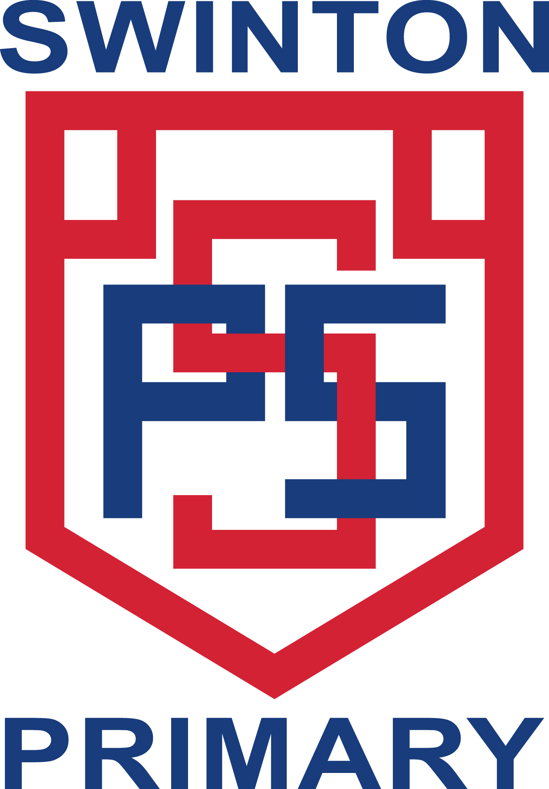
Swinton Primary School

Our Improvement Plan for 2023-24

Every year we work hard as a school community to improve our school to make the best it can be.
We ask everyone for their ideas about what we can do to improve.
Here are the things we are going to work on this year to make Swinton and its learners the best they can be.

We want learning and teaching to respect the rights of of our pupils and promote well-being and help pupils develop as successful learners, responsible citizens, effective contributors, confident individuals.

We want to support families and pupils to improve attendance.

