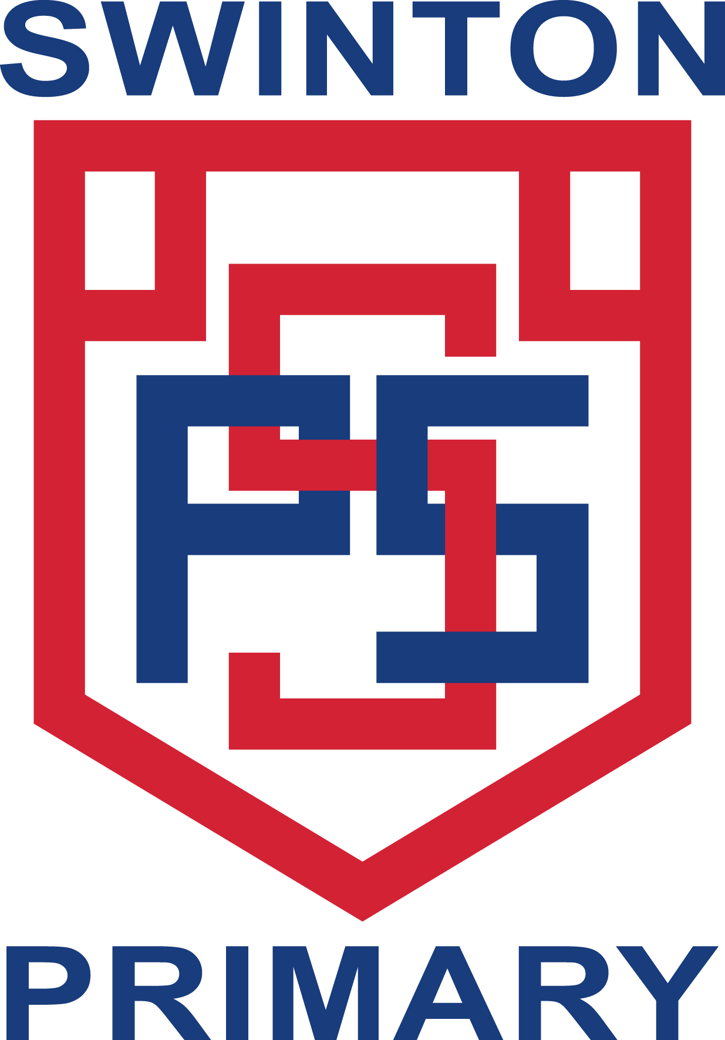
Swinton Primary School

Our Improvement Plan for 2023-24

Every year we work hard as a school community to improve our school to make it the best it can be.
We ask everyone for their ideas about what we can do to improve.
Here are the things we are going to work on this year to make Swinton and its learners the best they can be.

We will work on improving learning and teaching in Reading

We will work on improving learning and teaching in Writing

