SWINTON PRIMARY SCHOOL HANDBOOK

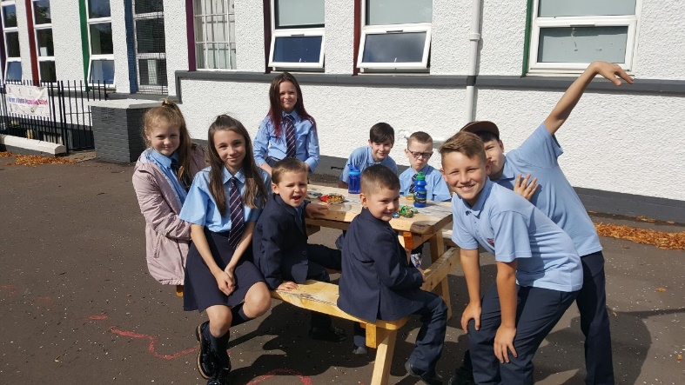

Swinton Primary School
Rhindmuir Road Baillieston
Glasgow

Tel No: 0141 771 1776
Email – headteacher@swinton-pri.glasgow.sch.uk
School Website – www.swinton-pri.glasgow.sch.uk
We are part of the Bannerman Learning Community

WELCOME TO SWINTON PRIMARY SCHOOL!

Dear Parents and Carers,

I’d like to give you a very warm welcome to Swinton Primary School. I am very proud of the hard work of all our children and staff to make Swinton a great place to learn and work.
I hope this handbook gives you a taste of ways in which we support learners and help them to grow into confident individuals and also a strong feeling of the ethos and values that underpin all we do in our school.
If you would like to see more you are always welcome to get in touch and pop in for a visit. We would love to show you all we do and the fun we have!
Mrs Emma Gillies
Headteacher

Our Vision For Swinton Primary

In Swinton Primary we strive to have children who feel happy and confident and proud of who they are, who are given the opportunity to be all they can be to reach their full potential in life.

We aim to provide the best possible education for our children by creating a school where everyone works together to ensure we all feel valued and respected. We do this by setting high expectations and ensure learners have exciting and challenging opportunities.

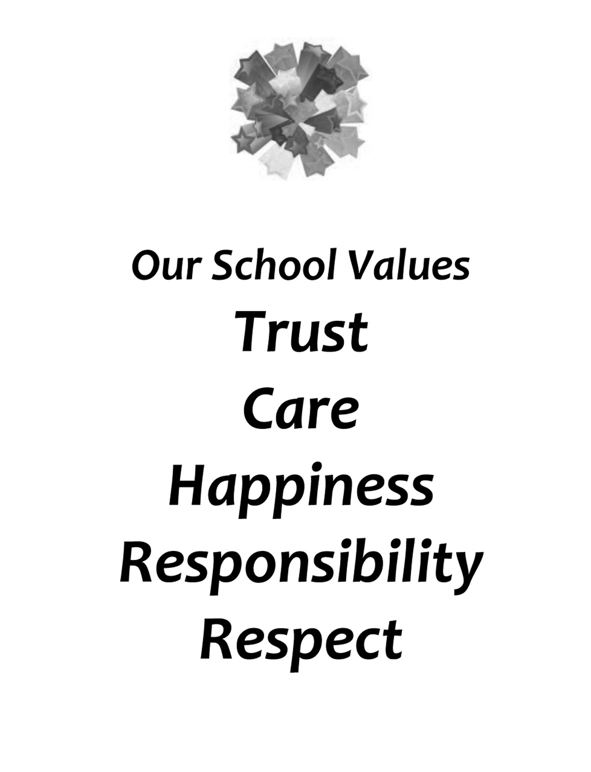

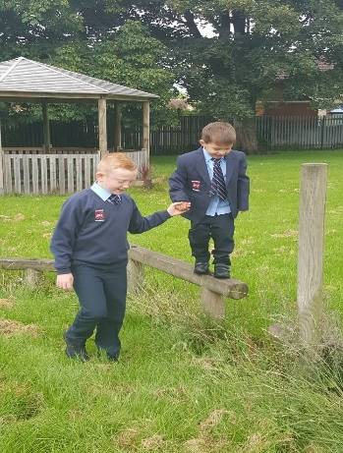
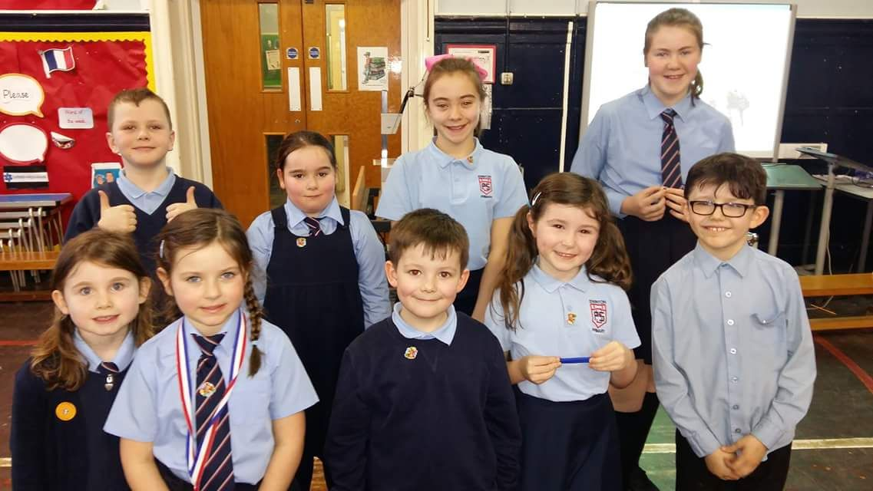

OUR SCHOOL

Swinton is a suburban school set in its own grounds, within the Glasgow boundary. It has its own grass playing field, completely fenced and bordered with a great variety of trees and shrubs.
There are nine classes at present. The number of pupils in each class does not exceed 33 and in most cases is less.
Staff and pupils enjoy a happy, relaxed relationship in a small school such as Swinton. It takes a very short time for all new-comers to become known to the others, and each child is known by name to all teachers. From the beginning we treat every child as an individual, and do our best to cater for the individual needs of each.
The school is non-denominational and caters for children of both sexes from Primary 1 to Primary 7.

Parents should note that the working capacity of the school may vary dependent upon the numbers of pupils at each stage and the way in which the classes are organised.

SCHOOL HOURS

Opening time 9am.
Morning Interval 10.30 to 10.45am.
Lunch 12.15 to 1.00pm.
Closing time 3.00pm.

Glasgow City Council provides a Breakfast Club to all pupils from 8.00am to 8.45am, this service is free to children who receive free school meals and there is a charge of £2 for all other pupils, £1 for additional siblings.
We do not have any after-school care in the building but other local after-school care facilities pick up from Swinton.

ENROLMENT

Each year, a date for the registration of entrants will be announced in the press. Parents interested in seeking a place in our school should enroll using the online application process on Glasgow City Council website.
When children have enrolled, arrangements will be made for them to be brought to school in the summer term to meet their teacher and visit Primary 1 classroom. This familiarisation helps the children to settle in when the new term starts.
Any parent of a child out with the new entrant system should contact the Head Teacher in the first instance.

School Term Dates

Details of school term dates are available on the Glasgow City Council website: https://www.glasgow.gov.uk/index.aspx?articleid=17024

CURRICULUM

Curriculum for Excellence 3-18
Curriculum for Excellence has been introduced to raise standards of learning and teaching for all 3 to 18 year olds. It aims to help prepare children and young people with the knowledge and skills they need in a fast changing world. As part of Curriculum for Excellence all children from pre-school to the end of S3 will receive a rounded education known as a Broad General Education(BGE). Curriculum for Excellence is all about bringing real life into the classroom and taking lessons beyond it.
Through the experiences we provide at Glasgow Primary School we want our children to become Successful Learners, Confident Individuals, Responsible Citizens and Effective Contributors. We are committed to providing children with a broad general education and focus on eight curriculum areas.

Expressive Arts | Health & Wellbeing | Languages | Mathematics
Religious & Moral | Sciences | Social Studies | Technologies
Progress in learning is indicated through curriculum levels as detailed below.

Level | Stage
Early | The pre-school years and P1 or later
First | To the end of P4, but earlier or later for some
Second | To the end of P7, but earlier or later for some
Third & Fourth | S1-S3, but earlier for some

Expressive arts: The inspiration and power of the arts play a vital role in enabling our children and young people to enhance their creative talent and develop their artistic skills.

Science: Science and its practical application in healthcare and industry is central to our economic future, for our health and wellbeing as individuals and as a society.

Social Studies: Through social studies, children and young people develop their understanding of the world by learning about other people and places both past and present, societies, their beliefs and values.

Religious and moral education: Religious and moral education includes learning about Christianity, Islam and other world religions, and supports the development of beliefs and values.
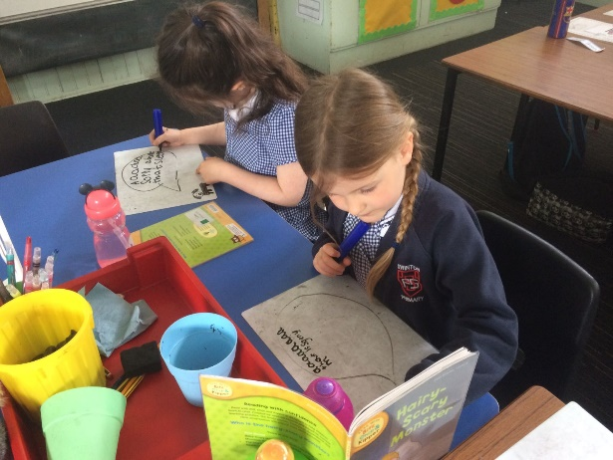

Literacy:
READING
Reading is a critical tool for lifelong learning and our main aims are to encourage and teach children to read fluently with expression and understanding, and to develop a love for books.
We use Oxford Reading Tree, Storyworlds, Literacy World throughout the school. However teaching staff use a variety of other texts to ensure reading mileage. This includes novel studies newspapers, leaflets, catalogues, websites and blogs.
TALKING/LISTENING
We encourage children to express themselves confidently using the spoken word by creating opportunities in drama, discussion, story telling, games, poetry, speech making, debates and listening skills.
WRITING
Writing includes all forms of imaginative, functional and personal writing, which encourages the development of a range of skills.
This is supplemented by graded dictionaries, thesauruses, grammar books, our school Active Spelling Programme, school produced worksheet/cards all graded to suit each child's ability
MODERN LANGUAGES IN THE PRIMARY SCHOOL:
The Scottish Government’s policy, Language Learning in Scotland: A 1+2 Approach, is aimed at ensuring that every child has the opportunity to learn a modern language (known as L2) from P1 until the end of the broad general education (S3).
In Swinton Primary we have five teachers who are qualified to teach Spanish as a foreign language and one qualified to teach French as a foreign language. Pupils from P1 - 6 learn Spanish and French is introduced in P.6 and is carried on into P.7. This has been agreed in full consultation with the local secondary school and meetings between primary and secondary colleagues to help smooth the transition from primary to secondary in this subject area.

Numeracy and Mathematics:
Society requires young people who are sophisticated mathematical thinkers, pattern spotters and problems solvers, therefore we aim to empower our children as mathematicians. With this pathway we aim to provide opportunities for learning that promotes deep engagement with all areas of mathematics.
At Swinton, we are developing confidence in numeracy skills. Learners will envelop effective mental strategies and be able to apply them with speed and accuracy. Learners will be able to use and develop their numeracy skills within and out with the school, applying them in real life situations and across all aspects of learning.
Mathematics equips us with the skills we need to interpret and analyse information, simplify and solve problems, assess risk and make informed decisions.

Technologies: The range of subjects in technical education has changed significantly over the last two decades and now includes craft, design, engineering and graphics.
There will be opportunities throughout the year for parents and carers to learn more about aspects of the curriculum and to be consulted about significant changes if appropriate.

Useful websites www.curriculumforexcellencescotland.gov.uk www.educationscotland.gov.uk/parentzone/index.asp

Health and Well Being:

Learning in health and wellbeing ensures that children and young people develop the knowledge, understanding and skills which they need now and in the future to help them with their physical, emotional and social wellbeing. We cover a variety of Learning from Road Safety to Emotional health and resilience.

Religious and Moral Education:

Swinton Primary follows the authority’s policy relating to Religious Education and Religious Observance (1993).
Our school is fortunate to have a close link with St John’s Church in Baillieston. Their minister, Reverend Jim Benton- Evans, is our Chaplain and assists with the Christianity element of Religious and Moral Education and provides opportunities for religious observance. Parents have the right to withdraw their child from religious observance and should inform the school in writing.
All children attend Weekly assemblies held by Head Teacher and Depute Head Teacher which incorporate the development of pupils’ spiritual, social, moral and cultural values.
Parents have the right to request that their children be withdrawn from Religious Observance. Please contact Head Teacher in writing.
Parents and carers from religions other than Christianity may request that their children be permitted to be absent from school in order to celebrate recognised religious events. Only written requests detailing the proposed arrangements will be considered.

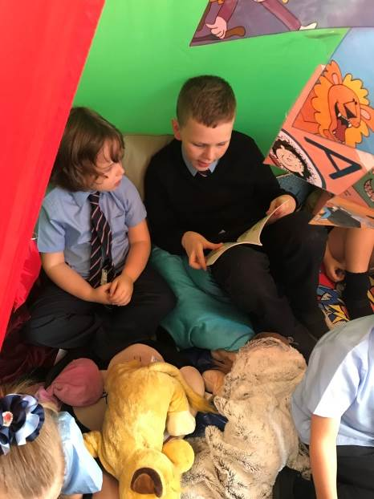

ASSESSMENT

Children’s work is assessed continuously and records of class, groups and individual progress are kept by the teacher. Pupils who have Additional Support Needs will have their Additional Support Plan reviewed on a termly basis ensuring that parents, pupils and staff are able to contribute their views. Flexibility in our grouping allows for transfer from group to group if an individual child makes particular progress or experiences difficulty. School Report cards are issued annually.

PARENT/TEACHER EVENINGS

These are arranged twice a year so that parents have an opportunity to discuss children’s progress with the teacher. Pupils are invited to attend these meetings to allow pupils ownership of their learning. Pupils are fully involved in discussions of progress and next steps. Where parents have cause for concern about their child, however, they are very welcome to call at the school at any time during the session. It would be appreciated if an appointment was made in advance, except in emergency. An annual ‘Get to Know You’ session takes place at the start of the session to build relationships with families and get to know your child.

PE KIT

P.E. kit should be brought to school on Monday and taken home on Friday. It is important that pupils come prepared to learn and for PE this requires appropriate clothing. All jewellery should be removed. Pupils who are not participating in PE must have a note or a medical certificate. Pupils who are unable to participate in practical PE should still bring their kit to allow them to assist in the lesson by refereeing, keeping scores or assisting with the distribution of equipment. This ensures that they are still able to take part in some way in the work of the class and do not miss out on the knowledge and understanding of the course.

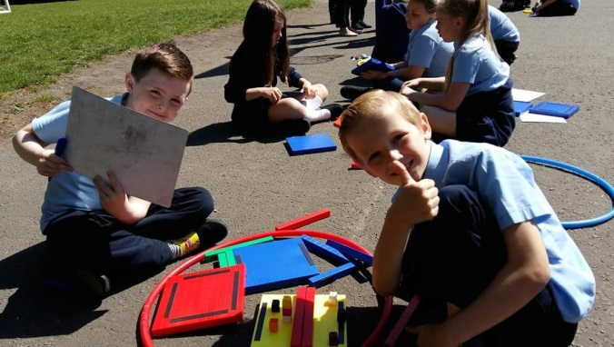

CHILD SAFETY/CHILD PROTECTION POLICY

All educational establishments and services must take positive steps to help children protect themselves by ensuring that programmes of health and personal safety are central to the curriculum and should have in place a curriculum that ensures that children have a clear understanding of the difference between appropriate and inappropriate behaviour on the part of another person, no matter who.
As with other areas of the curriculum, you will be kept informed of the health and personal safety programme for your child’s establishment.
Schools, establishments and services must create and maintain a positive ethos and climate which actively promotes child welfare and a safe environment by:
• Ensuring that children are respected and listened to
• Ensuring that programmes of health and personal safety are central to the curriculum
• Ensuring that staff are aware of child protection issues and procedures
• Establishing and maintaining close working relationships and arrangements with all other
agencies to make sure that professionals collaborate effectively in protecting children

Should any member of staff have concerns regarding the welfare or safety of any child they must report these concerns to the head of establishment, the head, or the person deputising for the head, after judging that there may be grounds for concern regarding the welfare or safety of any pupil must then immediately advise the duty senior social worker at the local social work services area office of the circumstances.

SUPPORT FOR PUPILS

The school has a duty to ensure that all pupils have equal access to the curriculum, with appropriate support for their needs if required. This applies to the content of lessons, teaching strategies and minor adaptations to the school environment. There are a wide range of factors which may act as a barrier to learning. We are committed to working closely with parents and carers to ensure that they are fully involved in any decisions about support for their children’s needs.
Any parent or carer seeking further advice regarding this policy should contact the Headteacher in the first instance.
Further information relating to additional support needs is available on the Glasgow City Council website at https://www.glasgow.gov.uk/index.aspx?articleid=18941
Information on the Glasgow City Councils’ Parental Involvement Strategy can also be found at https://www.glasgow.gov.uk/index.aspx?articleid=17870

GETTING IT RIGHT FOR EVERY CHILD (GIRFEC)

The GIRFEC approach is about how staff in all children’s services meet their needs by working together where necessary to ensure that children reach their full potential. www.scotland.gov.uk/gettingitright

MANAGEMENT CIRCULAR NO. 57 – CHILD PROTECTION GUIDELINES

Summary of Reporting, Recording and Monitoring Procedures: Public Display

A concern prompted by any of the following should be reported in accordance with the stated procedures outlined below:

a specific incident;
a disclosure made by a child or parent/carer;
information from a third party;
adult behaviours/circumstances that may place the child at risk of harm;
child behaviours/circumstances that may place the child at risk of harm;
a culmination of minor concerns over a period of time.
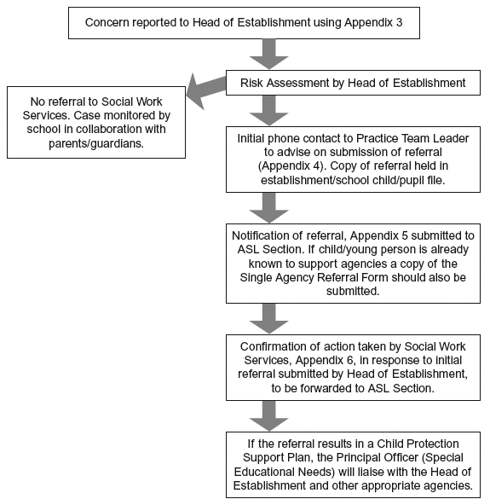

The ASL Section will monitor all referrals and provide termly reports to the Department Child Protection Group. The reports will also inform returns to the Child Protection Committee.

HOME AND SCHOOL LINKS

A welcome awaits all parents who are interested in visiting the school for any reason whatsoever, although naturally it is more convenient if an appointment is made in advance.
Parental involvement in school affairs is actively encouraged.
At present we are greatly indebted to a group of parents, who give up their own time to help out with activities including fundraising, school trips and sports coaching. This help is very valuable to us, and may even be of some value to the parents who gain a greater insight into school life as a result.
School helpers working alone with pupils have PVG certificates for your child/ren’s safety
Parents are invited to Open Mornings and Parental workshops throughout the year to allow parents to engage in their child’s learning.

COMMUNICATION WITH PARENTS

At Swinton Primary School we use a variety of ways to keep in touch.

Open Door Policy – the senior leadership team are available for all parents and carers at any time providing they are not teaching or in another meeting. Please either pop in to the school office or phone for an appointment.
Newsletters – will be sent out on a regular basis to keep parents informed about the work of the school.
School App – Swinton Primary App can be downloaded free from Piota Schools App. This has useful information and important dates for your diary. (If you require assistance downloading this App, please contact the school office)
Emails/Letters – further information which requires a response may be sent out in letter form.
School website/ Facebook – will contain a great deal of information about the school. It is a good idea to check this regularly.
Text messaging – You may also receive text reminders about events/school closures etc.

Meetings - Parents and carers are welcome in the school to discuss any aspect of their child’s development and progress. To avoid disappointment, it is advisable to make an appointment. There are various opportunities throughout the year when parents can discuss their child’s progress with the class teacher and view the child’s work.
Parents and carers are welcome at other events throughout the school year e.g. workshops, information evenings, enterprise projects, Stay and Play, religious and other assemblies. The school newsletter and social media will keep you informed.

Pupil Absence
Within Glasgow Primary School good attendance is encouraged at all times. Parents are asked to advise if their son or daughter is going to be absent. This should be done as early as possible on the first day of absence. If the young person is going to be absent for some time, it would be helpful to know at the earliest opportunity. The school uses daily text messaging to inform parents and carers of absence if no contact is made. All unexplained absences are investigated by the school and appropriate action taken. All calls must be made to the Pupil Absence Reporting Line on 0141 287 0039. The line is open between 08.00-15.30 Monday to Friday. Alternatively you can use the online form on the Glasgow City Council website: https://www.glasgow.gov.uk/index.aspx?articleid=18832

EXTRA CURRICULAR ACTIVITIES
The children also compete in many competitions e.g. Glasgow School Athletics, Art Competitions, Respect Me Anti Bullying Competitions. We also fund-raise e.g. Children in Need.

Our children are encouraged to enter competitions with the attitude that it is fun to take part whether we win or lose.

OUT OF SCHOOL LEARNING AND STUDY SUPPORT
Staff and qualified coaches provide a variety of after school clubs including football, Dance, basketball, Golf, Art, Choir, Chess and Book clubs. These will vary on a termly basis and pupils will be given opportunities at different stages to experience a variety of clubs.

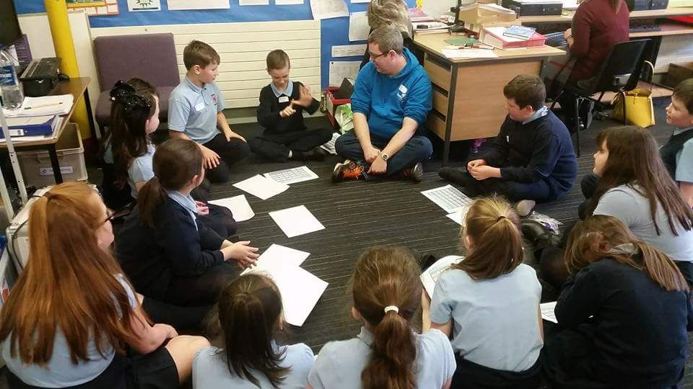

PROMOTING POSITIVE BEHAVIOUR
The relationship between pupils and teacher is similar to that between a child and his/her own parents requiring mutual consideration on both sides.
Swinton Primary is proud to be a Rights Respecting School and this means that children are taught from P1 to know and understand Children’s Rights and the responsibilities they have to allow others to access their rights.
Our ultimate aims are to foster self discipline, develop attitudes of courtesy and consideration in the community. Carefully constructed activities and duties giving our

children responsibility during their daily work, are designed to provide a measure of controlled freedom in which self-discipline, courtesy and consideration flourish. However, parents will understand a school must have rules. In the event of discipline/bullying problems, reasonable sanctions and co-operation will be applied as per school policy.
Problems of greater concern would involve full consultation with parents.
Children’s Rights as outlined in the UNCRC (United Nations Convention on the Rights of the Child) are fundamental to a good school ethos. Adults in our school will work with children to ensure they are aware of their rights and fully respect the rights of others. Therefore, the approach within Swinton Primary School is to build a positive ethos that demonstrates care and respect for all. Positive behaviour is recognised and celebrated. Our school operates a system of class charters to set out expected behaviour. This is celebrated through a variety of individual and class rewards.
The highest standards of behaviour are expected of pupils at all times. Where this is not the case, a variety of sanctions are used. Parents are asked to co-operate with the school in encouraging a sense of responsibility and good behaviour in their children.

SWINTON UNIFORM

Swinton Uniform consists of:
School tie, Blue shirt/blouse, Skirt/pinafore/ trousers navy (plain), Navy sweatshirt/cardigan/plain navy hoodie
Or Blue polo shirt AND/OR Navy sweatshirt/cardigan/plain navy hoodie, skirt/trousers/pinafore navy (plain)
Black shoes/ all black trainers

Please have ALL clothing marked with your child’s name as it is impossible to sort out unmarked belongings.

There are forms of dress which are unacceptable in school, such as items which:
potentially, encourage faction (such as football colours)
could cause offence (such as anti-religious symbolism or political slogans)
could cause health and safety difficulties, such as loose fitting clothing, dangling earrings.
are made from flammable material, for example, shell suits in practical classes
could cause damage to flooring, carry advertising, particularly for alcohol or tobacco: and
could be used to inflict damage on other pupils or be used by others to do so.

Our Parent Group has a gently used uniform stall at our Christmas and Summer Fayres.
We have school uniform ordering services which allow you to order online or from school, a range of uniform items. Please see the ladies in the office for further details.

CLOTHING AND FOOTWEAR GRANTS

Parents/Carers receiving Income Support, Job Seekers Allowance (Income Based), Working Tax Credit (check link below for thresholds), Housing Benefit, Council Tax Benefit or Universal Credit (check link below for thresholds) will normally be entitled to monetary grants for footwear and clothing for their children. Information and application forms may be obtained from schools and at
https://www.glasgow.gov.uk/index.aspx?articleid=17885

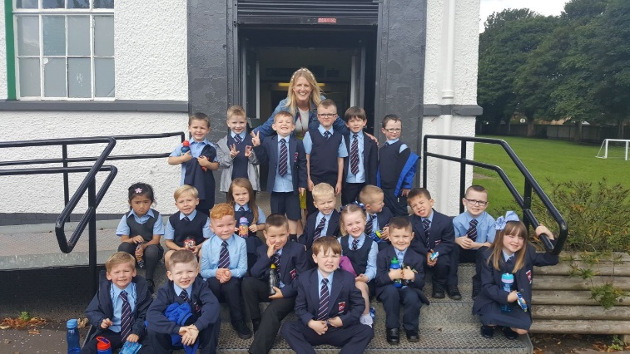

SCHOOL MEALS

Primary Fuel Zone
All services available in the Fuel Zone are developed in line with The Schools (Health Promotion and Nutrition) (Scotland) Act 2007 which aims to help children eat healthily during the school day and beyond.
Cordia supports Education Services to meet the requirements of the Act by providing healthy food and drink in schools to encourage Glasgow’s children to make the right choice in order to maintain a healthy lifestyle.

Breakfast Service
Glasgow’s Big Breakfast is available in all Glasgow primary schools every week day morning. Children can enjoy a nutritional breakfast of fruit juice, cereal and milk, toast and fresh fruit prior to the start of the school day. Children have the opportunity to socialise with their friends in a supervised and safe environment.

Lunch
Fuel Zone focuses on serving healthy food in a bright and informal environment where children can enjoy lunch. The menu in the Fuel Zone rotates on a three weekly basis giving children more variety at lunchtime.

All primary 1-4 pupils can enjoy lunch absolutely free.
Three meal choices are available daily: main meal, vegetarian or snack meal. Children can select from soup and bread, fruit and vegetables, yoghurt or jelly and milk to accompany their meal. A halal menu is also available if required please speak to the catering manager for further information.
All children who use fuel zone or have packed lunch are entitled to free milk.

Children who prefer to bring packed lunches will be accommodated in a suitable area.

Special Diets
If your child has a special medical diet requirement please seek a referral from your dietician and inform the Headteacher. If you plan to send your child/children to breakfast club, you should inform the staff of any medical dietary requirements.

Children and young people of parents/carers receiving Income Support, income-based Job Seekers Allowance, Working Tax Credit (check link below for thresholds), Child Tax Credit only (check link below for thresholds), Universal Credit (check link below for thresholds) and income-related Employment and Support Allowance are entitled to a free midday meal. Information and application forms for free school meals may be obtained at
https://www.glasgow.gov.uk/index.aspx?articleid=17885

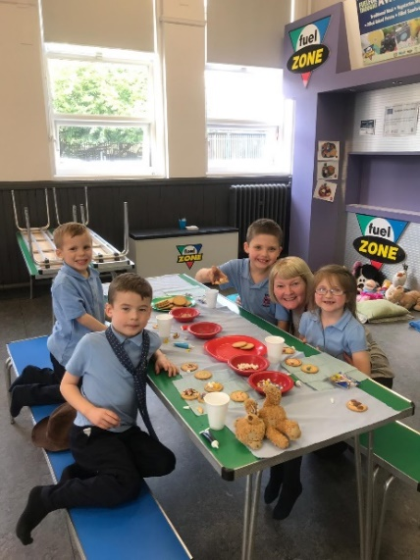

MEDICAL AND HEALTH CARE

If a child becomes ill during the course of the school day, he/she may require to be sent home. Please ensure that you keep the school informed of all contact details.
Parents should inform the school of any medical requirements relating to their child. If a child requires medication during the school day, parents must complete the appropriate medical form. This is available on request from the school office.

EMERGENCIES

We make every effort to maintain a full educational service, but on some occasions circumstances arise which lead to disruption. Schools may be affected by, for example, severe weather, temporary interruption of transport, power failures or difficulties of fuel supply.
In such cases, we shall do all we can to let you know about the details of our closure or re- opening by using letters, texts and the local media etc.

EMERGENCY CONTACT INFORMATION

At the start of each school session, parents will be issued with the annual data check form. Please ensure that this is completed and returned to the school. It is also important that you let us know if there are changes to your telephone number(s) or to those of your emergency contacts throughout the year.

Data Protection – use of information about children and parents/carers

We collect information about children attending school (and also about parents/carers, emergency contacts etc. provided in the annual data check) to allow us to carry out the Council’s functions as the education authority for the City of Glasgow. This may sometimes involve releasing personal information to other agencies and other parts of the Council, particularly in relation to child protection issues or criminal investigations, and it may also be used for research purposes (see the link below for more details regarding this).

Information held by the school is, in legal terms, processed by Glasgow City Council. The Council is registered as a data controller under the Data Protection Act 2018 and all personal data is treated as confidential and used only in accordance with the Data Protection Act, the General Data Protection Regulations, and the Information Use and Privacy Policy approved by the City Council. For more information on how we use personal information, or to see a copy of the Information Use and Privacy Policy, see https://www.glasgow.gov.uk/index.aspx?articleid=18010 .

Education specific privacy statements can be accessed at https://www.glasgow.gov.uk/index.aspx?articleid=22069 .

TRANSFER FROM PRIMARY TO SECONDARY SCHOOL

The associated secondary school for Swinton Primary School is Bannerman High School. Pupils work on a variety of projects throughout their P.6 and P.7 years to help them get to know staff at Bannerman High and also the year group of pupils with whom they will transfer. A two day visit is scheduled for May of each year. Pupils who need additional support can join the enhanced transition programme. Please contact the Head Teacher or Depute Head for further information. Arrangements for transfer to secondary normally begin in December.
Bannerman High School, Glasgow Road, Baillieston. Telephone No. 0141 582 0020

THE PARENT FORUM AND PARENT COUNCIL/ GROUP

The Scottish Schools (Parental Involvement) Act 2006 has changed the arrangements for parental representation in all schools. Since August 2007, all parents/carers are automatically members of the Parent Forum for their school and they have the right to establish a Parent Council to represent them.

Parent Forum – The membership of the Parent Forum is made up of all parent/carers who have a child/young person at an education authority school. Membership of the Parent Forum allows parents/carers to have a say in the local arrangements to enable their collective view to be represented on matters such as the quality and standards of education at the school and other matters of interest to parents/carers. One of the ways parents in the Parent Forum will be able to express their views is through the Parent Council/Group.
At Swinton we value Parents’ views. We want every Parent to have a voice and for it to be heard. At Swinton we have a Parent Group, made of up two members from the Parent Forum of each year group.

The role of Parent Group members:

To gather views, concerns, ideas from their year group Parent Forum. Members attend Parent Group meetings and discuss items on the agenda and agree actions. Minutes of meetings will be shared with all parents
To plan and organise fundraising events for the school
To encourage parental engagement in school and supporting the work of the school
Gathering and representing parents’ views to the Headteacher, education authority and HMIe
Promoting contact between the school, parents/carers, children and young people and the
local community
The Head Teacher has a right and duty to attend all meetings of the Parent Council, has the right to speak but no right to vote.

SCHOOL IMPROVEMENT

On an annual basis, you will receive a copy of our Standards and Quality report. Copies from previous years are available on the school website. The Standards and Quality report highlights progress in key curricular areas such as literacy, numeracy and health & wellbeing. Our priorities for improvement are detailed in our School Improvement Plan which is discussed with our Parent Group. Any parent or carer seeking a copy of the plan can contact the school office or check out our website.

HOME LEARNING

Continuing to learn at home helps children to achieve more and is a vital part of our partnership with parents. Please check your child’s schoolbag for communication about home learning and specific tasks. A copy of our home learning policy is available on the website and on request from the school office.

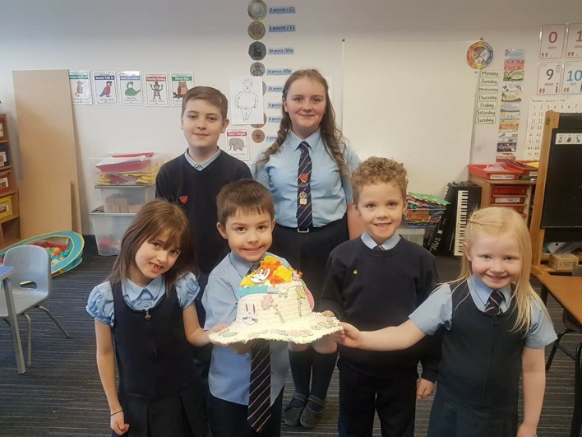

Comments & Complaints

In Glasgow Primary School we aim to have positive relationships across our school community. However, if you have a comment or complaint about any aspect of school life, please contact the Headteacher in the first instance.

Glasgow City Council complaints procedures are available : https://www.glasgow.gov.uk/index.aspx?articleid=16133

Customer Care Team
Customer & Business Services
Glasgow City Council
City Chambers
Glasgow G2 1DU

Tel: 0141 287 0900
e-mail: customercare@glasgow.gov.uk or education.customercare@glasgow.gov.uk

The above website also includes information on data protection and freedom of information.

