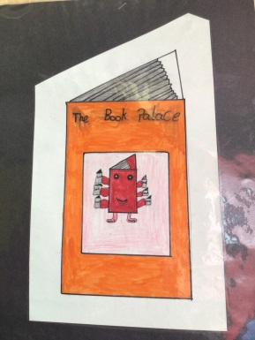
THe Book Palace

It is finally back!
Our wonderful library – The Book Palace – is now available to all our children once again!
The children have been borrowing books for the last few weeks and enjoying them in school.
Now, due to the on-going easing of Covid restrictions, our pupils can now take home the book they have borrowed.
Book loans will be for an initial period of 2 weeks and new books will be issued once each loan is returned.
We appreciate your support in ensuring all books are returned promptly to allow others to borrow the books.
Children will visit the library at least once each fortnight to renew their book. Your child’s teacher can advise you when their library time is.
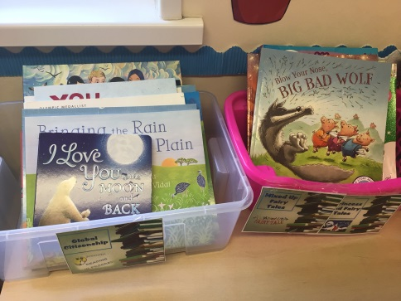
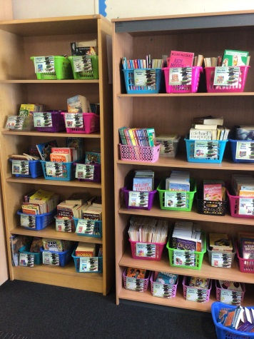
We hope you will help us to continue to instil a love of reading at home and at school.
Many thanks,

Ms Maxwell
