
Access to the Glasgow Schools ICT System

Acceptable Use Policy Annual Reminder
The ambition for Glasgow Schools is that information and communication technology will become an integral part of the educational experience of every young person. As a Glasgow School pupil, you are being given access to one of the most advanced information and communication technology (ICT) systems available at any school in the UK. This ICT System will provide access to extensive curricular software, email and the Internet for all. The objective is to give you the best possible grounding in the skills necessary to succeed in the information age.

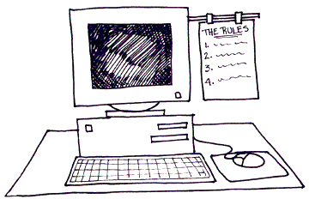
As with all resources available within school deliberate misuse of the ICT System will be subject to the school’s disciplinary procedures and sanctions.

What is expected of you?

Acceptable Use of the ICT System

- You must always get permission from a teacher before using the ICT System or accessing any information or application.
- You must keep secret your personal login and password for the ICT System and never allow others to use them.
- You must not attempt to access any part of the ICT System that is not part of your personal desktop.
- You must not intentionally damage or vandalise any part of the ICT System (including computer, monitor, keyboard, mouse, printer, cable etc) or delete any computer software used on the ICT System or the data of another user.
- You must not intentionally introduce software designed to cause damage to any component part of the ICT System software (commonly known as a virus).
- All pupils should note that it is all too easy to damage computer equipment through spillage of food and drink and there is a risk of injury where liquids come into contact with electrical appliances.
- You must always end your session on a computer by closing it down correctly. If you are unsure how to close down, you should ask your teacher.
- You must not use the ICT System for business, or other commercial activities including product advertisement or political lobbying.

Acceptable Use of E-mail and the Internet

You are responsible for good behaviour on the Internet and should consider your e-mail communications as being similar in all respects to any conversation in a classroom or a school corridor. General school rules apply. In addition the following acts are prohibited:

- Sending or displaying any abusive, sexist, racist or otherwise offensive material.
- Using obscene language.
- Accessing or attempting to access any inappropriate or offensive material.
- Violating copyright laws.
- Failing to report known instances of any of the above.

Remember, everything that you do on the system will be automatically recorded and the people who operate the ICT System will monitor your compliance with this Acceptable Use Policy.

