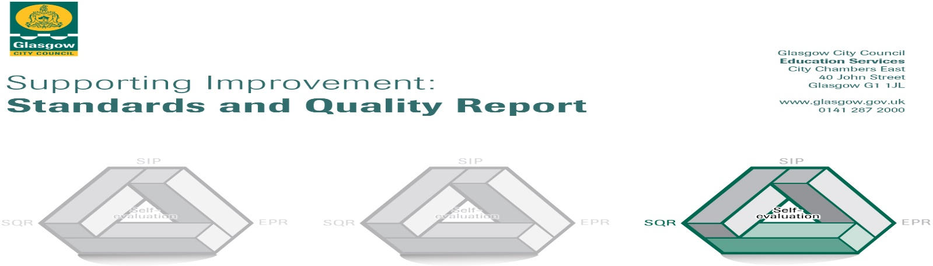

The summary report is provided for parents/careers and partners to outline our achievements this session and our priorities for next session. Throughout this session we have taken forward our priorities as detailed in our school improvement plan. Through our processes of self-evaluation, we have identified how we can improve outcomes for our children and young people.

Our achievements and improvements this year.
We would like to highlight the following improvements/achievements:

- Key developments (leadership of change) QI 1.3
- Developments in learning and teaching and assessment Q1 2.3
- Progress in promoting well-being equality and inclusion QI 3.1
- Progress in children’s learning /raising attainment and recognising achievement QI 3.2

Key Developments
Through our School Improvement Planning last session the development work on Growth Mindset has had a very positive impact on pupils learning. Pupils can demonstrate a sound knowledge of Growth Mindset and can explain how this has helped them in their learning. We have a whole school Mighty Mindset display which shows examples of work which have allowed children to demonstrate their Growth Mindset. Having a Growth Mindset is also celebrated during our termly achievement assembly. Children through their learning log can identify the importance of mistakes in the learning process. Teachers are now building in more time for reflection during lessons to allow children to self-assess progress and to seek out more challenging learning opportunities if necessary.
Our improvement work on Numeracy and Maths last session has resulted in staff and pupils reporting an increase in positive attitude and motivation towards numeracy. Pupils have benefitted from new innovative practices for teaching and learning within maths, this has led to an increase in depth of understanding, mental agility and overall attainment. Parents report pupils are more willingly tackle challenging aspects of Numeracy and maths and they have more strategies to do this.

Progress in promoting well-being, equality and inclusion
We continue to have a very positive ethos of the school, as a Rights Respecting School this impacts all we do. Teachers plan exciting and engaging learning experiences for children and work hard to develop their individual skills and talents. Commitment and teamwork from all staff to ensure that all the children and happy, safe and achieving their potential.
Our SHANARRI room has been created and is used by pupils who are struggling to cope with pressures of the playground. The SHANARRI room is a supervised sensory area where children can do quiet, mindful activities to help them stay calm and relaxed.
We also have a My Space room, this is a place where children can go if they are struggling with their emotions and need to be calm.
Seasons for Growth groups have been established by the ADHT and is supporting pupils who have experiences loss or bereavement.
We are an accredited Language and Communication Friendly Establishment and we continue to develop our knowledge and practices to ensure we effectively support pupils with Language and communication difficulties.
Every year pupils participate in a Health Week, activities include judo, yoga and running taster sessions, Bikeability session, healthy eating campaigns and tasting sessions and meditation and mindfulness activities. Pupils enjoy the activities and many report they would continue some of the healthy options they tried during the week.

Developments in learning and teaching and assessment
Each week pupils work with their class teachers to discuss their learning and next steps. New weekly learning logs allow pupils time for reflection on successes they have had and what strategies helped them to achieve these. They then reflect on the attitude and Mindset they will strive to have the following week to enable them to improve.
The implementation of a new approach to Numeracy teaching and learning has had a very positive impact on pupils’ attitude towards Numeracy and Maths. Pupils challenge themselves more and are equipped with a better range of strategies for mental maths. Pupils are developing their skills at self- evaluating as they are allowed to choose which challenge is best for them.

Progress in children’s learning /raising attainment and recognising achievement

In 2016-17 most pupils in P1, P4 and P7 achieved the appropriate Curriculum for Excellence Level in Literacy, Numeracy and Health and Well Being.
We are very proud of Swinton pupils’ achievements and we celebrate these each week at our whole school assemblies as well as during our termly achievement assembly. Each class has an achievement wall where pupils’ achievements are displayed and celebrated.
Through pupil voice activities such as whole school committees, captains’ surgery and ‘Let’s Do Lunch!’ alongside our monitoring and tracking calendar it is evident that pupils are motivated, engaged and progressing in their learning through the experiences they are provided with. Financial education week and Book Launch have provided pupils with real life learning contexts and develop skills work and life.

This session we have offered clubs including Football, Basketball, Netball, Athletics, Dance, Chess, Sign Language and Scripture Union. Participation and skills developed at these clubs are celebrated during our annual Prize Giving Ceremony.
As well as attending clubs, we also give pupils opportunities to achieve through our school committees and Masterclasses which the pupils have been very positive about. All pupils have the opportunity to be part of a whole school committee and there are a variety of other ways they can show a strong pupil voice across the school.

Here is what we plan to improve next year.
- Pupils have increased engagement in their learning and Health and Well-being.
- Improve professional dialogue between teachers to ensure assessments track progress and allow teachers to better plan for next steps in pupils’ learning
- Encourage and foster parental engagement in children’s learning
- Increase the use of digital literacy to support pupils’ learning
- Increase in the number of children who read for enjoyment.
- Develop the curriculum in Literacy to raise attainment
- Raising attainment in numeracy linked to Glasgow’s attainment challenge.

How can you find out more information about our school?
Please contact us directly if you require further information or if you wish to comment on the report.

The contact e-mail address is: headteacher@swinton-pri.glasgow.sch.uk

Our telephone number is: 0141 7711776

Our school address is: 2 Rhindmuir Road, Glasgow, G69 6AZ

Further information is available in: newsletters, the school website, and the school handbook

