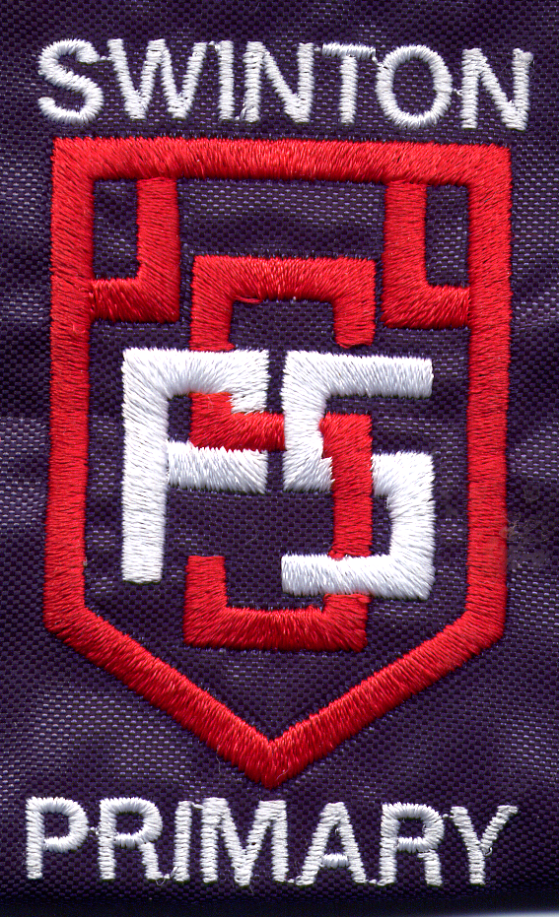
The Values we chose for our school are
Trust
Care
Happiness
Responsibility
Respect


We will be working hard to learn about what these values mean to us and our school community. We all want to live by these values to make sure our school vision comes to life.

If you would like more information on the Vision and Values for our school please contact the headteacher.

Swinton Primary School
Our School
Vision & Values

To be the best
we can be we need…….

Everybody in our school community took part in updating our school vision and vales. We thought long and hard about the kind of school that we want to be.
We created statements to outline our vision for our school. Then staff, pupils and parents voted on which statements they felt most reflected their vision.
From this our school vision was created.

In Swinton Primary we strive to have children who feel happy and confident and proud of who they are. Who are given the opportunity to be all they can be to reach their full potential in life.

We aim to provide the best possible education for our children by creating a school where everyone works together to ensure we all feel valued and respected. We do this by setting high expectations and ensure learners have exciting and challenging opportunities.

We know that remembering our school vision will be at the heart of everything we do in the future and it is underpinned by key values. We want to be sure that everyone in our school knows and remembers our key values and this will be a major focus for our Health & Wellbeing work next session.

We worked on selecting our key values the same way as our vision statement and all stakeholders got the chance to vote on the values that they felt were most important. We all had similar ideas.

School Values Votes
Pupils | Parents | Staff
Trust | Trust | Equality
Friendship | Happiness | Determination
Caring | Honesty | Caring
Responsibility | Responsibility | Responsibility
Respect | Respect | Respect

