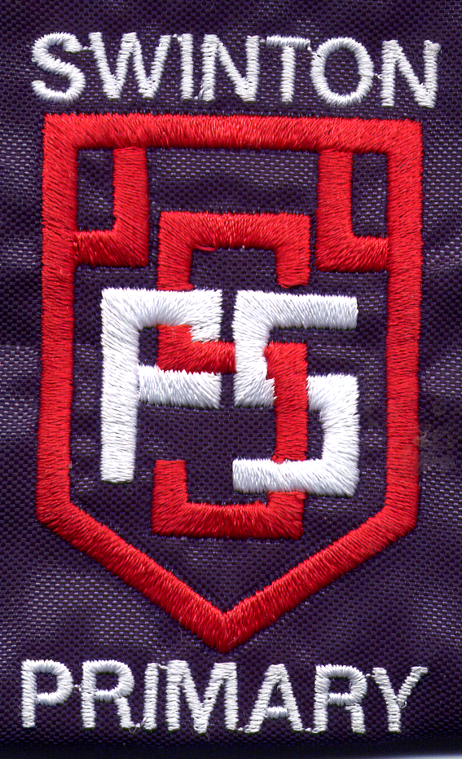

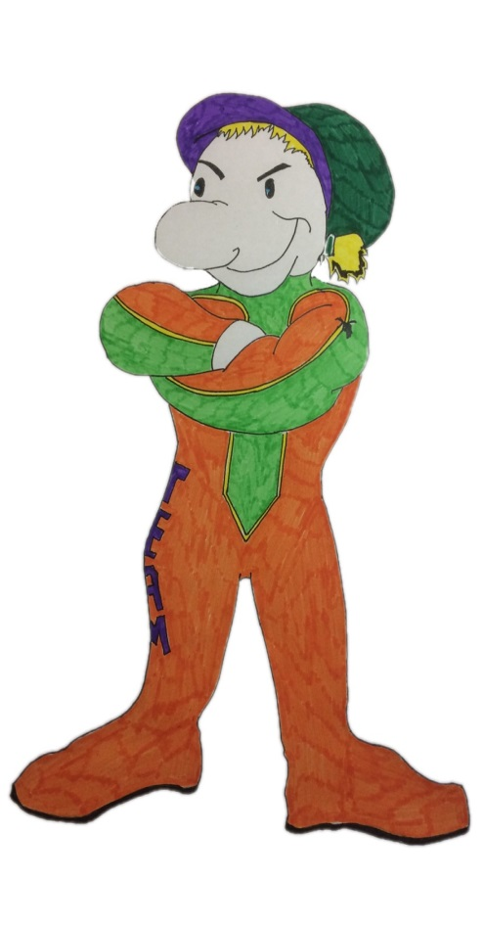

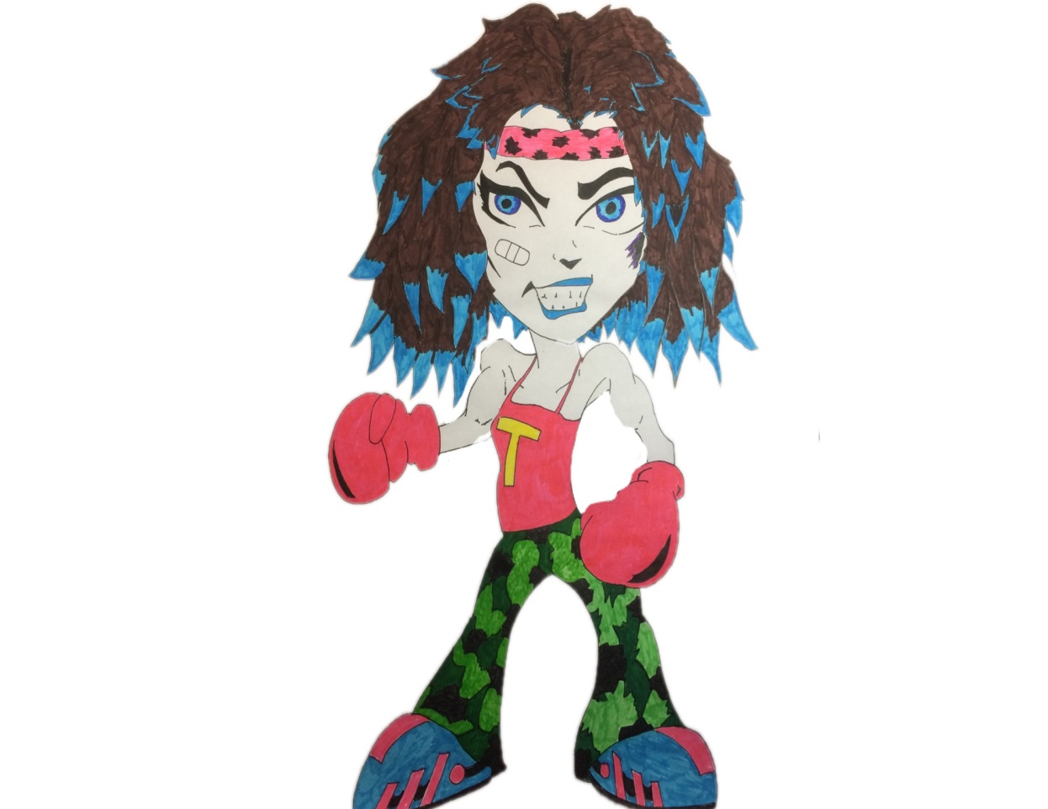
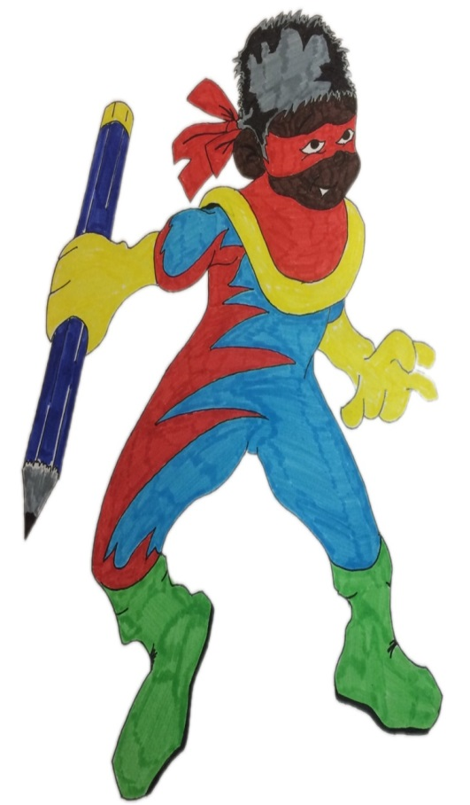

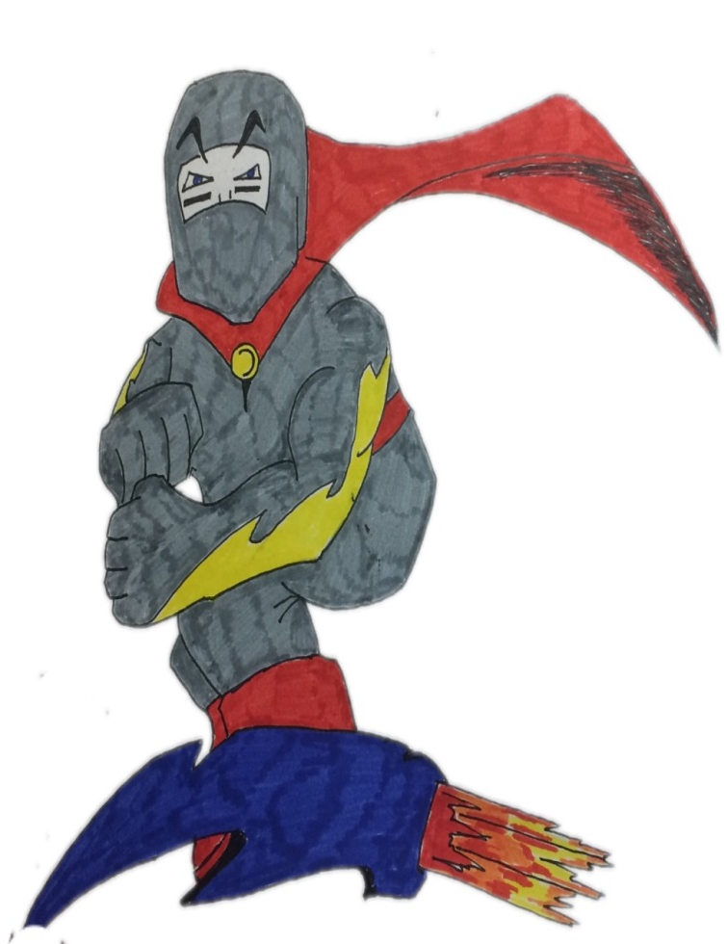

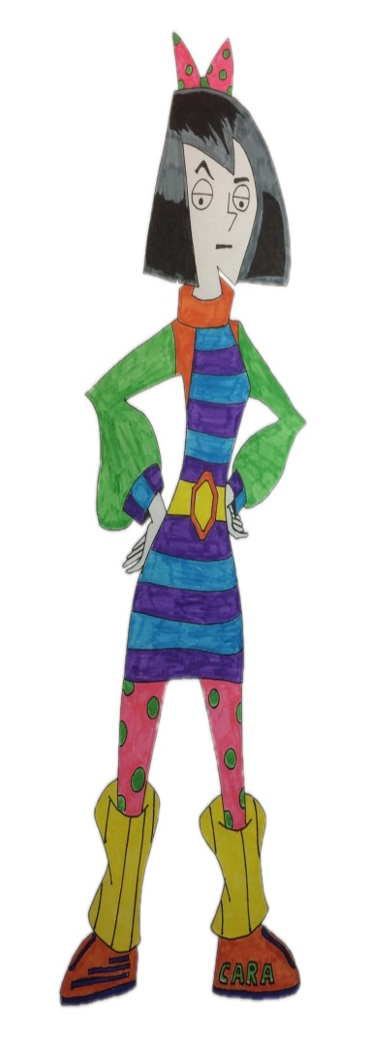
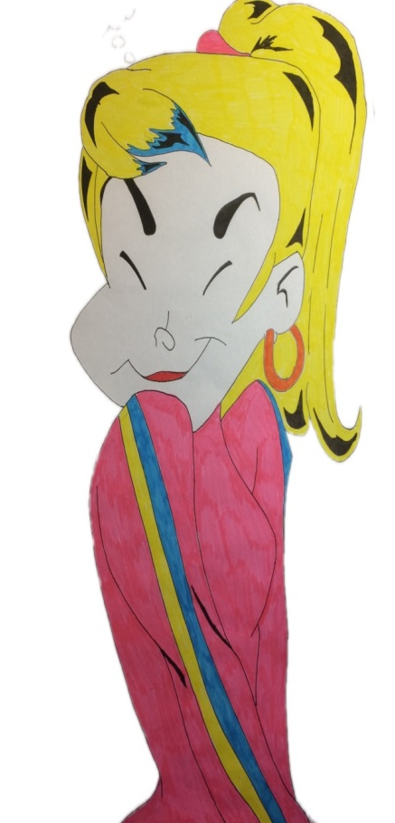

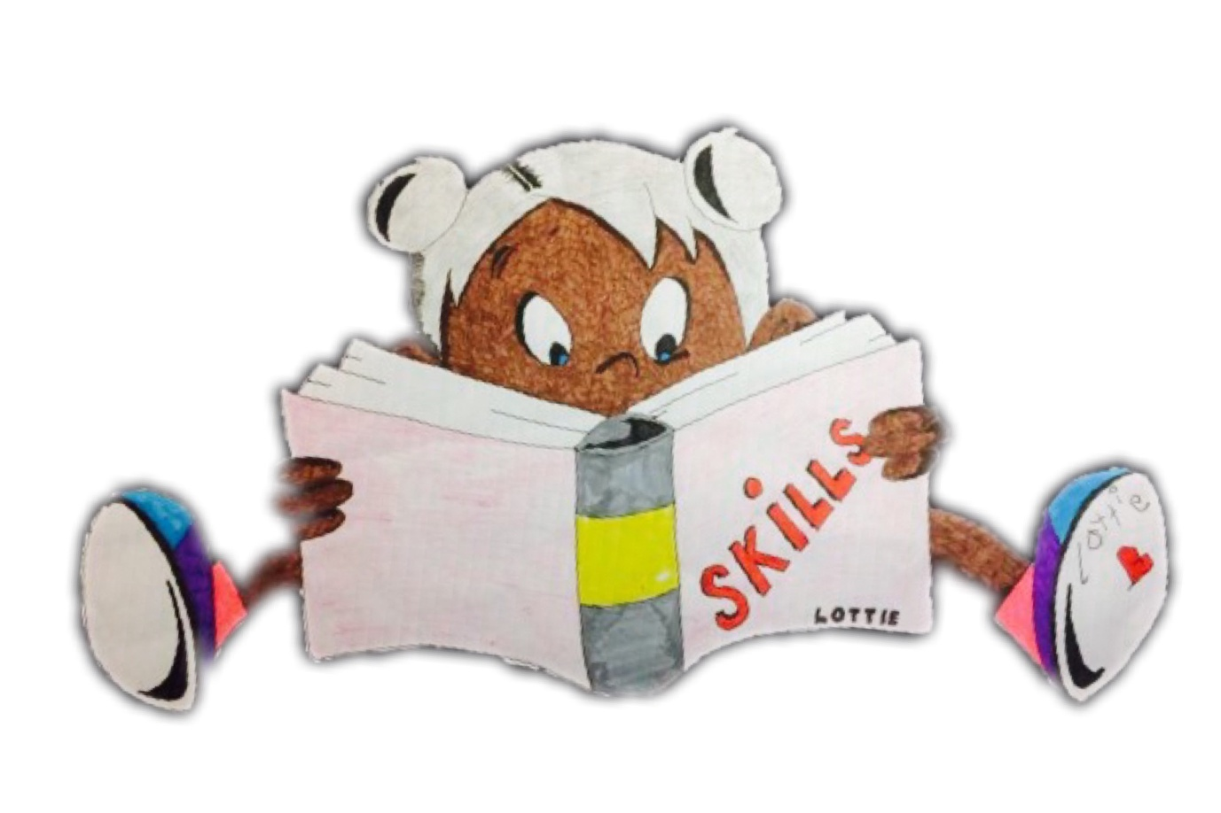
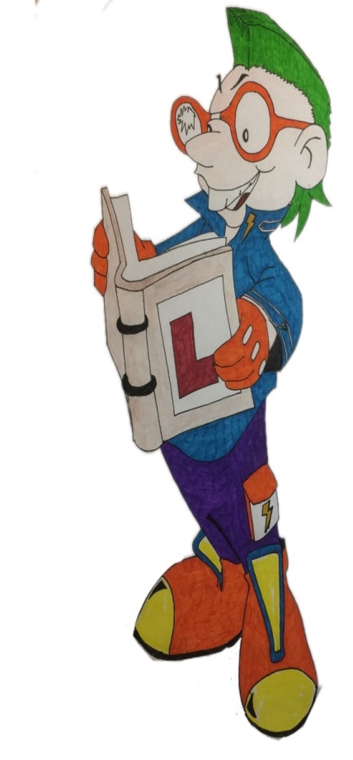

Swinton Primary School
Celebrating Success
Term 1 Achievement Assembly
17th December 2019


To be the best
we can be we need…
Trust, Care, Happiness
Responsibility& Respect

At the end of every term in Swinton Primary we have a special whole school assembly to celebrate our children’s achievements both in school and out of school. We thought it would be nice to share this fantastic news with parents & carers.
Values Award
P1 Myla McArthur
P2/1 Finlay Trivett
P2 Mollie O’Brien
P3 William Fisher
P4 Chloe Brown
P5/4 Ellen Dong
P6/5 Ava Tyczynski
P6 Eve Livsey
P7 Robert Ainslie

Rights Respecting School Awards
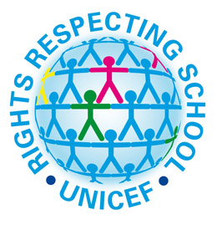
P1 Callie Hamilton
P2/1 Carla MacKinnon
P2 Robbie Allen
P3 Dylan Gauley
P4 Ben Devine
P5/4 Hayley Brett
P6/5 Lucas Wright
P6 Conner Aird
P7 Logan Doyle

Library Legend - For looking after the books in the Imagination Station, showing respect for others while they are reading and loving our library
Jack Scott, David MacKinnon, Eva Murdoch, Jude Hutton, Gabriel Dawson, Jack Connelly, Maisie Baggley, Kailyn McCall, Euan Barbour.

Questioning Master - for asking questions to show you are interested in learning – just like Questioning Quinn.
Thomas Fagan, Alistair Logan, Mia McGurgan, Aaron Robertson,
Corey Martin, Charlie Burrell, Orla Leishman, Darcy McCulley,
Preston Campbell.
Creative Thinking – for thinking of different ideas and solutions – just like Creative Callum.
Carter Samson, Garry Morris, Angel Aird, Aaron Haining, Finlay Conroy, Jorgie Kerr, Sam Black, Kirk Simpson, Cole Webster.
Mastering Mistakes - for recognising that mistakes are important because you can learn from them - just like Max the Mistake Maker.
Robbie Logue, Jay Mackay, Sophia Gallagher, Aaron Jack Adams, Robbie Leishman, Neve Defalco, Rory McKinstray, Arran McIntyre,
Jack Cassidy.
Learning Legend - for sharing enthusiasm for learning and enjoying a challenge - just like Learning Lucy!
Jude Carr, Carson Roden, Macie Mallon, William Smith, Kylie Roden, Noah Haining, Blake Marshall, Ava Burry, William Owens.
Fabulous Focus - for managing distractions and focusing on their work - just like Concentrating Cara!
Rowan Simpson, Rachel McMurdo, Emma Wright, Sophia Watts, Carson Callaghan, Ryan McKinlay, Eilidh McNicol, Aarron Ross,
Ava Mackay.
Top Team Player - for working with others and being co-operative - just like Tom the Team Player!
Alyssa O’Donnell, Myles Mitchell, Aiden Murray, Jack Hamilton,
Rhea McPhee, Elliot Mackay, Emily-Claire McFadden, Billy Eardley,
Ethan Green.
Showing Resilience - for never giving up - just like Tough Tina!
Harley Philp Leah Connor, Paul Tincknell, Elliott Owens, Tyler Ralston, Sophia Paterson, Corey Dickson, Erin Murray, Ryan Meikle.
Practising Poppy - for continuing to practise new skills and develop new abilities - just like Practising Poppy!
Owen Dong, Ross Thomson, Eva Baillie, Queenie Chen, Mollie Defalco, Layla Calman, Olivia Bain, Kalvyn Ferguson, Olivia Ross.

