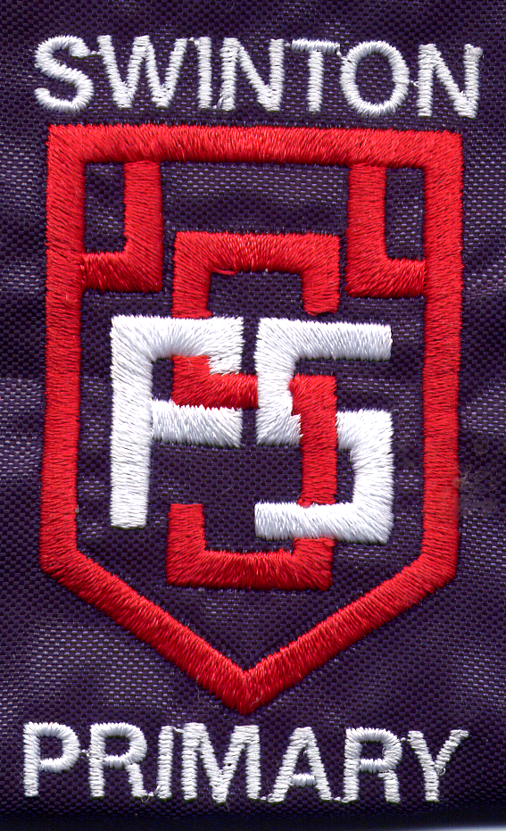

Swinton Primary School
Rhindmuir Road
Baillieston
Glasgow G69 6AZ

0141 771 1776

Date: 14th February 2020

Dear Parent/Carer,

I am writing to remind you not to park immediately outside the school gates on the yellow zig-zag lines as this endangers the lives of all our children. Parking on the zig-zags is making it dangerous for pupils.

Please always park safely and considerately, this means even for a few minutes to drop off your child.

Next week, we will be continuing to campaign for safe parking. This will include continued work with the Community Police and JRSOs, who will be out outside the school helping spread our safety message. You will also notice our new Parking Buddies which were purchased from the Parent Group Fund, these will hopefully act as reminders for safe parking. Thank you very much to Parent and Carers for their fundraising efforts to enable us to buy these signs.

We are also holding Safe Parking competitions in school and having a non-uniform day raise awareness with our pupils.

We appreciate your cooperation of this important matter of safety.

Yours sincerely,

Emma Gillies

Headteacher




